7/3/2020 ML

One Year Life Expectancy Post Thoracic Surgery Using IBM Watson

INTRODUCTION:

Cancer is a disease in which cells in the body grow out of control and is one of the most serious health problems in the world. Among various different types of cancer, lung cancer is one of the leading causes of death in both men and women. According to World Health Organization, it was observed that in the year 2018 2.09 million cases of lung cancer was registered and a total of 1.76 million died due to lung cancer. One of the reasons for the high death rate due to lung cancer is the late detection of the lung cancer. Also, the treatment and the prognosis depend on the type of the lung cancer, the stage and the patient’s performance. Once the lung cancer is detected, possible treatments include thoracic surgery, chemotherapy and radiotherapy.

At present, there are few biological or technical methods to prevent cancer. Therefore, the project focuses on the early detection of the lung cancer which is the vital factor in the treatment which will in turn increase the survival rate post the treatment. Also, if lung cancer is detected, an attempt is made to predict the survival of the patient for a minimum span of one-year Post Thoracic Surgery which will assist the doctors to take the proper decision for the medication. The project develops a system that detects the lung cancer by processing the Computed Tomography (CT) image of the lungs under test. The system uses Convolution Neural Network (CNN) which takes CT scan lung images which is present in Digital Imaging and Communications in Medicine (DICOM) format as input and further outputs whether the image is cancerous or non-cancerous. If lung cancer is detected, further the life expectancy post thoracic surgery can be predicted using the Machine Learning techniques. Thus, the system can be taken as an aid for the doctors to effectively make decisions for the treatment of lung cancer patients.

OVERVIEW:

Lung Cancer is a disease characterized by the uncontrolled cell growth in tissues of the lungs. It is one of the dangerous and life taking disease in the world. Early detection of lung cancer helps in identification of the treatment to be given which in turn increases the chances of survival of the lung cancer infected patient. This paper presents an approach which utilizes Convolution Neural network (CNN) to classify the CT lung images as cancerous or non-cancerous. The accuracy obtained by means of CNN is 95% which is more efficient when compared to accuracy obtained by the traditional neural network systems. Once the cancer is detected the paper also presents an approach to predict the life expectancy of the lung cancer infected patient post thoracic surgery. The prediction part is implemented using Machine Learning techniques. Linear Discriminant Analysis gave an accuracy of 83.76% with a F-measure of 0.83 which is more compared to other machine learning algorithms used.

Purpose:

Through this repository we can:

1.

2.

3.

Apply the fundamental concepts of machine learning from an available dataset

Evaluate and interpret my results and justify my interpretation based on observed data set Create notebooks that serve as computational records and document my thought process.

The analysis is divided into four sec ons, saved in juypter notebooks in this repository 1. Identifying the problem and Data Sources

https://eu-

gb.dataplatform.cloud.ibm.com/data/jupyter2/runtimeenv2/v1/wdpx/service/notebook/conda2py361254feaf150945e6bd9168002d100682/d … 1/1

7/3/2020 ML

2.

3.

4.

Exploratory Data Analysis

Pre-Processing the Data

Build model

Literature Survey:

EXISTING PROBLEM:

1:Patients who receive thoracic surgery for lung cancer do so with the expectation that their lives will be prolonged for a sufficient amount of time afterwards.

- The problem to solve is whether there is a way to determine postoperative 1 year survival of lung cancer patients utilizing the patient attributes in the data set.

PROPOSED SOLUTION:

Disha Sharma et al. (2011), proposed an approach for the early detection of lung cancer by analyzing lungs CT images using Image Processing techniques[1]. The authors used bit-plane slicing, erosion and Weiner filter image processing techniques to extract the lung regions from the CT image. Further the extracted lung regions were segmented using Region growing segmentation algorithm and later Rule based model was used to detect the cancerous nodules. With the help of diagnostics indicator, it was observed that the proposed method achieved an overall accuracy of 80%.

Hamid Bagherieh et al. (2013) gave a methodology to detect and classify the lung nodules using Image processing and Decision- Making techniques[2]. Initially, image preprocessing was carried out on a CT images by using contrast enhancement and linear filtering. Next, the filtered image was segmented using Region growing Segmentation process. Further the features like area and color was given as input to the Fuzzy system which employed fuzzy membership function to find the abnormalities.

Sindhu V et al. (2014), proposed an approach where the authors aimed to classify the survival of lung cancer patients post thoracic surgery[3]. The authors used Naïve Bayes, PART, J48, OneR, Random Forest and Decision stump algorithm techniques to classify the target function. The performance measurement shows that Random Forest gave high accuracy of 95.65% compared to other ML techniques used.

Prashant Naresh et al. (2014), proposed a methodology to detect the lung cancer using Image processing and Neural Techniques[4]. Initially the CT image of lung was filtered to remove Gaussian white noise and Otsu’s threshold technique was used to do the segmentation of the image. The structural and features were extracted and these features were given as input to the classifier. The SVM and ANN techniques were used for the classification and it was found that SVM techniques gave a higher accuracy of 95.12%.

Kwetishe Joro Danjuma (2015), proposed a methodology to predict the one- year survival of the patient post thoracic surgery[5]. Naïve Bayes, J48 and Multilayer Perceptron algorithms were used to classify the target class. The Naïve Bayes gave an accuracy of 74.4%, J48 gave an accuracy of 81.8% and MLP gave an accuracy of 82.4%.

Abeer S Desuky et al. (2016), proposed a methodology to predict the post-operative life expectancy after Thoracic Surgery using attribute and selection ranking by using Simple Logistic, Multilayer Perceptron and J48 techniques[6]. The Simple Logistic gave an accuracy of 84.68%, MLP gave an accuracy of 81.28% and J48 gave an accuracy of 84.47%.

Peyman Rezaei et al. (2017), proposed a methodology to predict the one-year survival of lung cancer patients post thoracic surgery using the combination of Bayesian Network (BN) and Uniform counts discretization[7]. Both BN and Uniform counts discretization yielded an accuracy of 91.28%.

https://eu-

gb.dataplatform.cloud.ibm.com/data/jupyter2/runtimeenv2/v1/wdpx/service/notebook/conda2py361254feaf150945e6bd9168002d100682/d … 2/2

7/3/2020 ML

Wafa Alakwaa et al. (2017), demonstrated a CAD system for lung cancer classification of CT scans with unmarked nodules[8]. Thresholding was used as initial segment approach which produced best lung segmentation. A modified U-Net trained on LUNA16 data was used to detect nodule candidates. The U-Net output were fed into 3D Convolutional Neural Networks (CNNS) to ultimately classify CT scans as positive or negative for lung cancer. The 3D CNNS produced a test set accuracy of 86.6%.

PROPOSED SYSTEM

A system is developed which detects the lung cancer from the given input CT scanned lung images which are in DICOM (.dcm) format. In addition to this, the system also helps to predict the Life Expectancy Post Thoracic Surgery of the Lung Cancer infected patients.

BLOCK DIAGRAM:
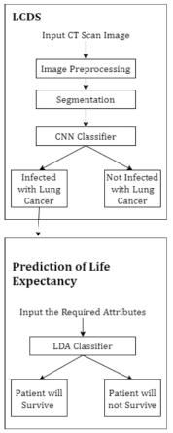

The CNN model is used to train the CT scanned lung images. Total of 776 images are used to train the network and 90 images are used to validate the network. The Lung Cancer Detection System undergoes the following steps:

- Image Preprocessing.

- Image Segmentation.

https://eu-

gb.dataplatform.cloud.ibm.com/data/jupyter2/runtimeenv2/v1/wdpx/service/notebook/conda2py361254feaf150945e6bd9168002d100682/d … 3/3
7/3/2020 ML

  - Training the CNN model.

- Image Preprocessing

Here, the image originally of size 512 X 512 is filtered and further the image is resized using OpenCV’s resize method by using the INTER_CUBIC interpolation.

B. Image Segmentation

Segmentation is the process of partitioning a digital image into multiple segments with the aim to simplify or change the representation of the image into something that is more meaningful and easier to analyze. Here the Watershed Segmentation is used to include the voxels from the edges. Fig-2(a) specifies the original slice of the Lung CT scan image in the gray scale. Fig-2(c) specifies the final segmented lung image produced after applying the watershed segmentation.
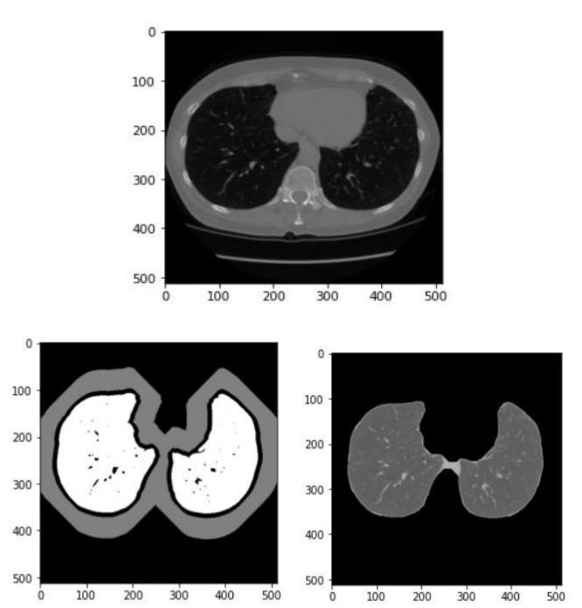

(a)


(b) (c)

Training the CNN model

Here, 776 images are used to train the CNN model where each image is either labelled as zero indicating the noncancerous image or one indicating the cancerous image.

https://eu-

gb.dataplatform.cloud.ibm.com/data/jupyter2/runtimeenv2/v1/wdpx/service/notebook/conda2py361254feaf150945e6bd9168002d100682/d … 4/4
7/3/2020 ML
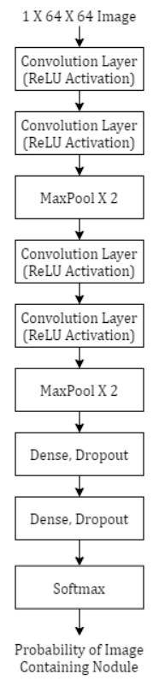

Architecture of CNN

Fig-3 summarizes the layers used in the Lung Cancer part. CNN also called ConvNet is a class of deep neural networks which is based on shared- weights architecture and translation invariance characteristics. In CNN, the network employs a mathematical operation called Convolution. Convolution is a specialized kind of linear operation. A CNN consists of an input and an output layer with the multiple hidden layers between input and output layer.

The input image is fed into the first convolution layer which uses 4 filters of size 3 X 3 with a ReLU activation. ReLU is the abbreviation of rectified linear unit which applies the non-saturating activation function f(x) = max(0, x). It effectively removes negative values from an activation map by setting them to zero. Further one more convolution layer is used with 4 filters of size 3 X 3 with a ReLU activation. Further pooling is applied which progressively reduce the spatial size of the representation to reduce the number of parameters and computation in the network. Pooling layer operates on each feature map independently. In the LCDS system, Max Pooling is used with a 2 X 2 window and a stride of 2. Next, again a convolution layer with the 8 filters of size 3 X 3 is used with ReLU activation. The above layer is repeated again. Then the Max Pooling function is applied with the same window size and stride as the precious one. Next a dense layer of

https://eu-

gb.dataplatform.cloud.ibm.com/data/jupyter2/runtimeenv2/v1/wdpx/service/notebook/conda2py361254feaf150945e6bd9168002d100682/d … 5/5
7/3/2020 ML

size 32 is used which acts as a classic fully connected neural network. Next a dropout layer is used to tackle overfitting where the dropout value of 0.5 is used. One more dense and the dropout layer is used with the same parameters. At last a SoftMax loss is used for predicting a single class out of K mutually exclusive classes.

The Sequential CNN model is compiled with a Stochastic Gradient Descent (SGD) optimizer which is an iterative method for optimizing an objective function with suitable smoothness properties. In this system, the learning rate of 1e-2, decay of 1e-6, momentum of 0.9 and nesterov of ‘True’ value is used as parameters for SGD. Also, the model is compiled with the ‘categorial_crossentropy’ loss.

Prediction of Life Expectancy

This is the second part of the system which aims at predicting the survival of lung cancer infected patient post thoracic surgery.

The dataset includes 17 attributes which are specified in Table- 1. Among all those attributes, Risk1Y is the target class specifying zero if the patient survives for at least one-year post thoracic surgery and one for those who died before completing one-year post surgery.

The visualization of the dataset is done using the Matplotlib and Seaborn libraries of Python. Further the essential attributes are found based on the Information Gain (IG) attribute evaluation which is used to find the importance of an attribute by using the Information Gain with respect to the target class.

IG (Class, Attribute) = E (Class) – E (Class | Attribute)

where, E stands for Entropy

After the IG Attribute Evaluation on all the 16 independent attributes in the dataset, it is found that the attributes PRE19 and PRE32 gives the IG value as zero and hence are the least useful attributes for training the model. Therefore, these two attributes are eliminated and the remaining 14 attributes are used to train the model.

Dataset Attributes

Name | Description | Type
DGN | Diagnosis – specific combination | Nominal
 | of ICD-10 codes.
PRE4 | Forced Vital Capacity – FVC | Numeric
PRE5 | Forced Expiratory Volume – FEV! | Numeric
PRE6 | Performance Status – Zubrod | Nominal
 | Scale
PRE7 | Pain before Surgery | Binary
PRE8 | Haemoptysis before Surgery | Binary
PRE9 | Dyspnoea before surgery | Binary
PRE10 | Coughing up blood before | Binary
 | surgery
PRE11 | Weakness before Surgery | Binary
PRE14 | T in clinical TNM-size of original | Nominal
 | tumor,
 | From OC11 (smallest) to

https://eu-

gb.dataplatform.cloud.ibm.com/data/jupyter2/runtimeenv2/v1/wdpx/service/notebook/conda2py361254feaf150945e6bd9168002d100682/d … 6/6
7/3/2020 ML

 | OC14(largest)
PRE17 | Type 2 DM – Diabetes Mellitus | Binary
PRE19 | MI up to 6 months | Binary
PRE25 | PAD – Peripheral Arterial Disease | Binary
PRE30 | Smoking | Binary
PRE32 | Asthma | Binary
AGE | Age at the time of Surgery | Numeric
RISK1Y | 1 Year Survival (T-Died, F- Alive) | Binary
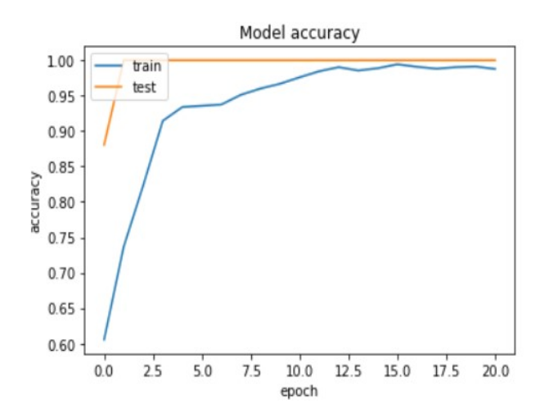

Chart-1: Accuracy of CNN model
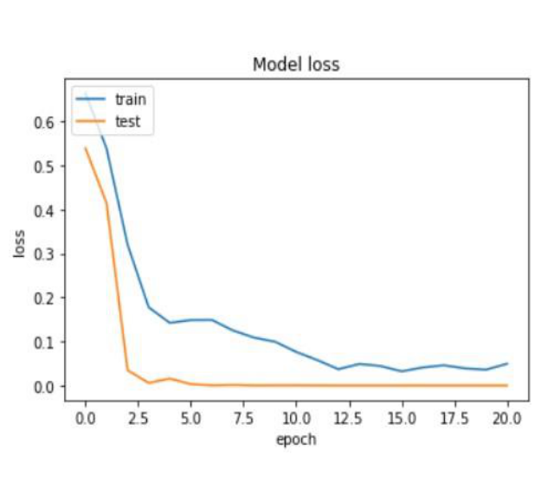

Chart-2: Loss of CNN model
Chart- 1 shows the graph of the accuracy with respect to the epochs. It’s observed that as the epochs increases, the accuracy of the model also increases. Further Chart-2 shows the loss function and it can be clearly seen that the loss decreases with increase in the epochs.

It is observed that the CNN model gave an accuracy of 95%.

https://eu-

gb.dataplatform.cloud.ibm.com/data/jupyter2/runtimeenv2/v1/wdpx/service/notebook/conda2py361254feaf150945e6bd9168002d100682/d … 7/7
7/3/2020 ML

RESULT

The 10-fold Cross Validation is used to train and test the dataset over mainly 4 algorithms that were specified before.

Accuracy alone is not enough to tell which model is the best one and hence along with the accuracy, the F-measure is also calculated to evaluate the model. Accuracy and Fmeasure are the parameters calculated from the Confusion Matrix representation as shown in Table-2.

Table-2: Confusion Matrix

 |  | Predicted Value
CONFUSION MATRIX |  | P | N
Actual | P | TP | FN
Value | N | FP | TN

Table-3: Performance Evaluation of Classifiers

 |  | Measures
Classifier | Accuracy | Precision | Recall | F-
 | (%) | (%) | (%) | Score
Random | 81.80 | 83.09 | 81.60 | 0.82
Forest
LDA | 83.76 | 82.59 | 83.76 | 0.83
SVC | 78.43 | 81.50 | 78.43 | 0.80
Logistic | 82.60 | 80.54 | 82.61 | 0.81
Regression

Accuracy: It’s the percentage of observation that are correctly predicted by the model.

Accuracy = (TP + TN) / (TP + TN + FP + FN)

where,

TP – True Positive

FP – False Positive

TN – True Negative

FN – False Negative

F-Measure: It’s also called F-Score which is a harmonic mean of the precision and recall.

F-measure = (2 * Precision * Recall) / (Precision + Recall) where,

Precision = TP / (TP + FP)

Recall = TP / (TP + FN)

Table-3 specifies the accuracy, precision, recall and FMeasure of the four algorithms used. It’s observed that the Random Forest, LDA, SVC and Logistic Regression gave an accuracy of 82.6%, 83.76%, 78.43% and 81.6% respectively. Therefore, its clear that among the four classifiers used, Linear Discriminant Analysis (LDA) gave the highest accuracy of 83.76% with the F-Measure of 0.82.

https://eu-

gb.dataplatform.cloud.ibm.com/data/jupyter2/runtimeenv2/v1/wdpx/service/notebook/conda2py361254feaf150945e6bd9168002d100682/d … 8/8
7/3/2020 ML

To train the dataset the following algorithms are used:

https://eu-

gb.dataplatform.cloud.ibm.com/data/jupyter2/runtimeenv2/v1/wdpx/service/notebook/conda2py361254feaf150945e6bd9168002d100682/d … 9/9
7/3/2020 ML
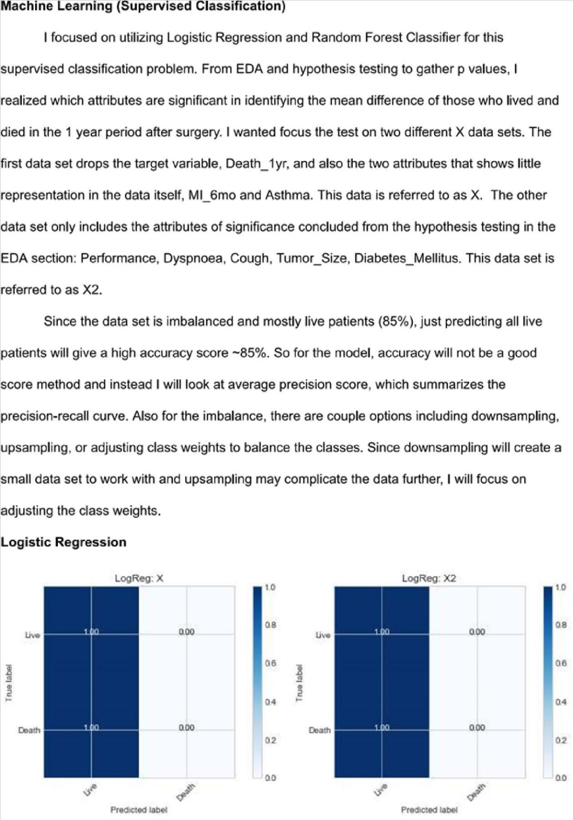

https://eu-

gb.dataplatform.cloud.ibm.com/data/jupyter2/runtimeenv2/v1/wdpx/service/notebook/conda2py361254feaf150945e6bd9168002d100682/d … 10/10
7/3/2020 ML
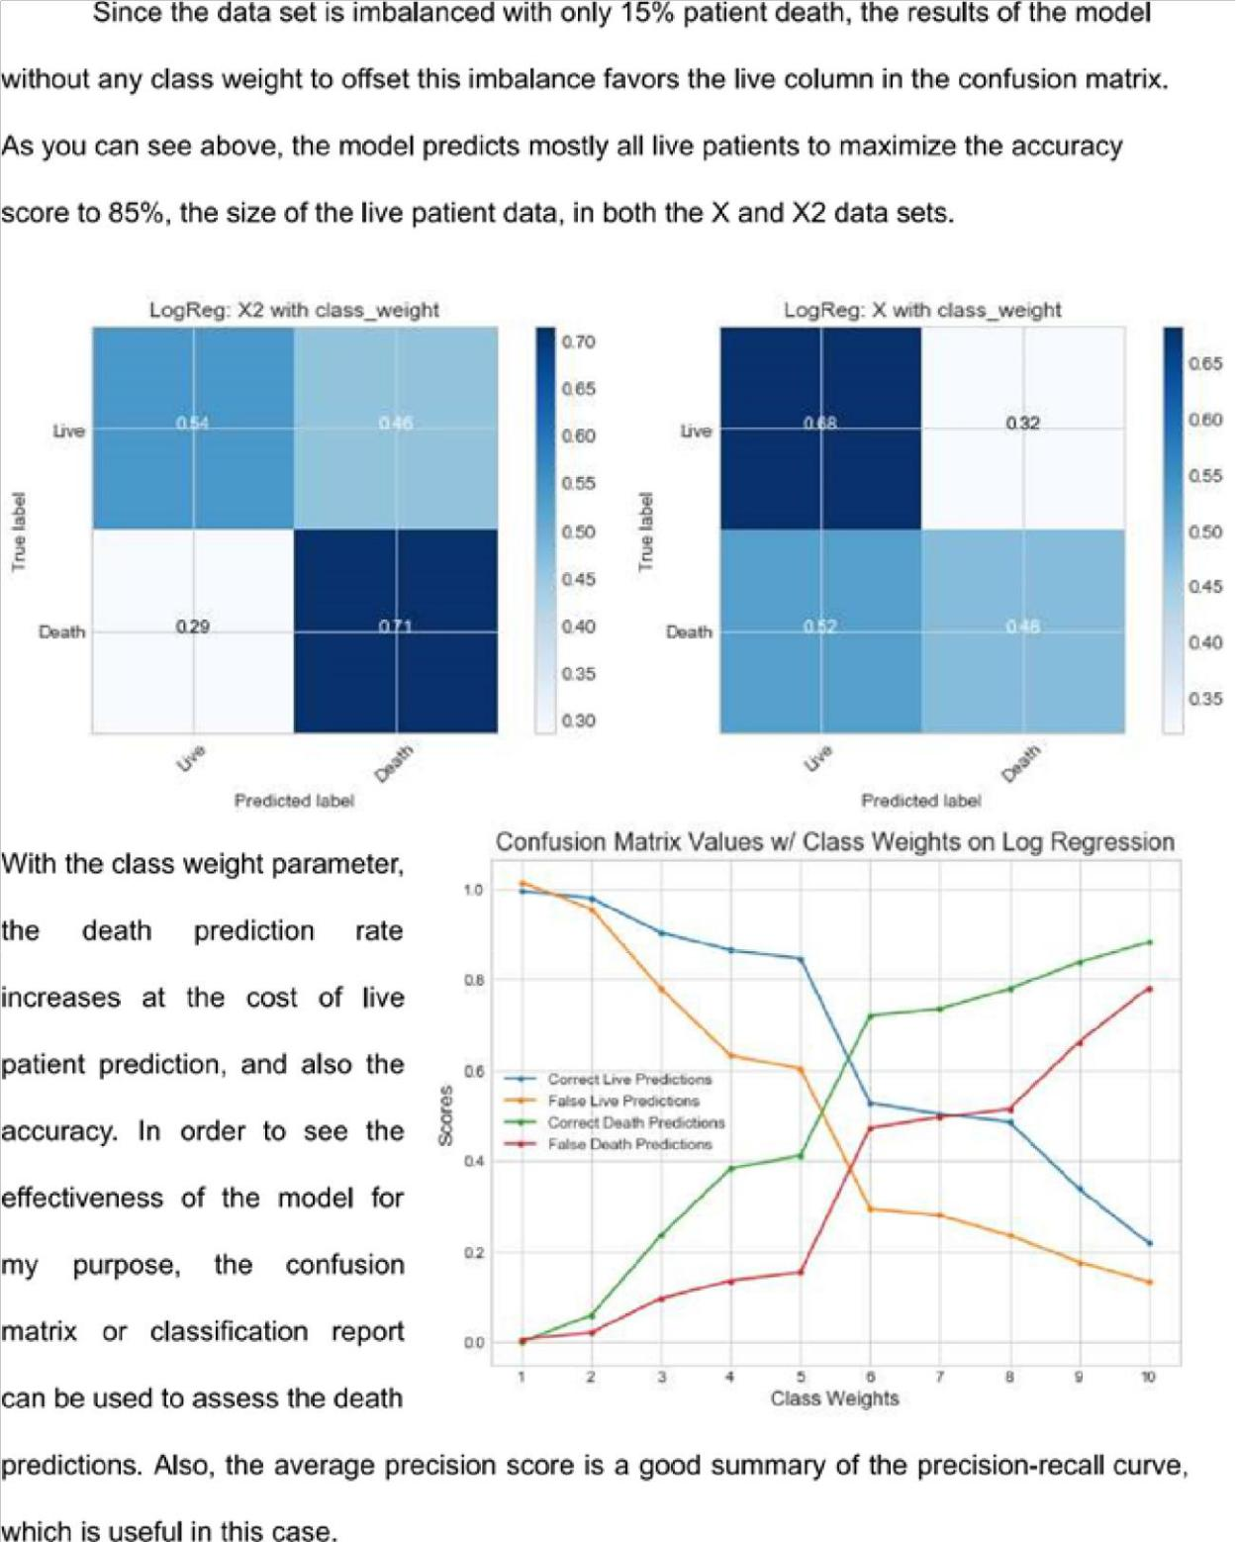

https://eu-

gb.dataplatform.cloud.ibm.com/data/jupyter2/runtimeenv2/v1/wdpx/service/notebook/conda2py361254feaf150945e6bd9168002d100682/d … 11/11
7/3/2020 ML
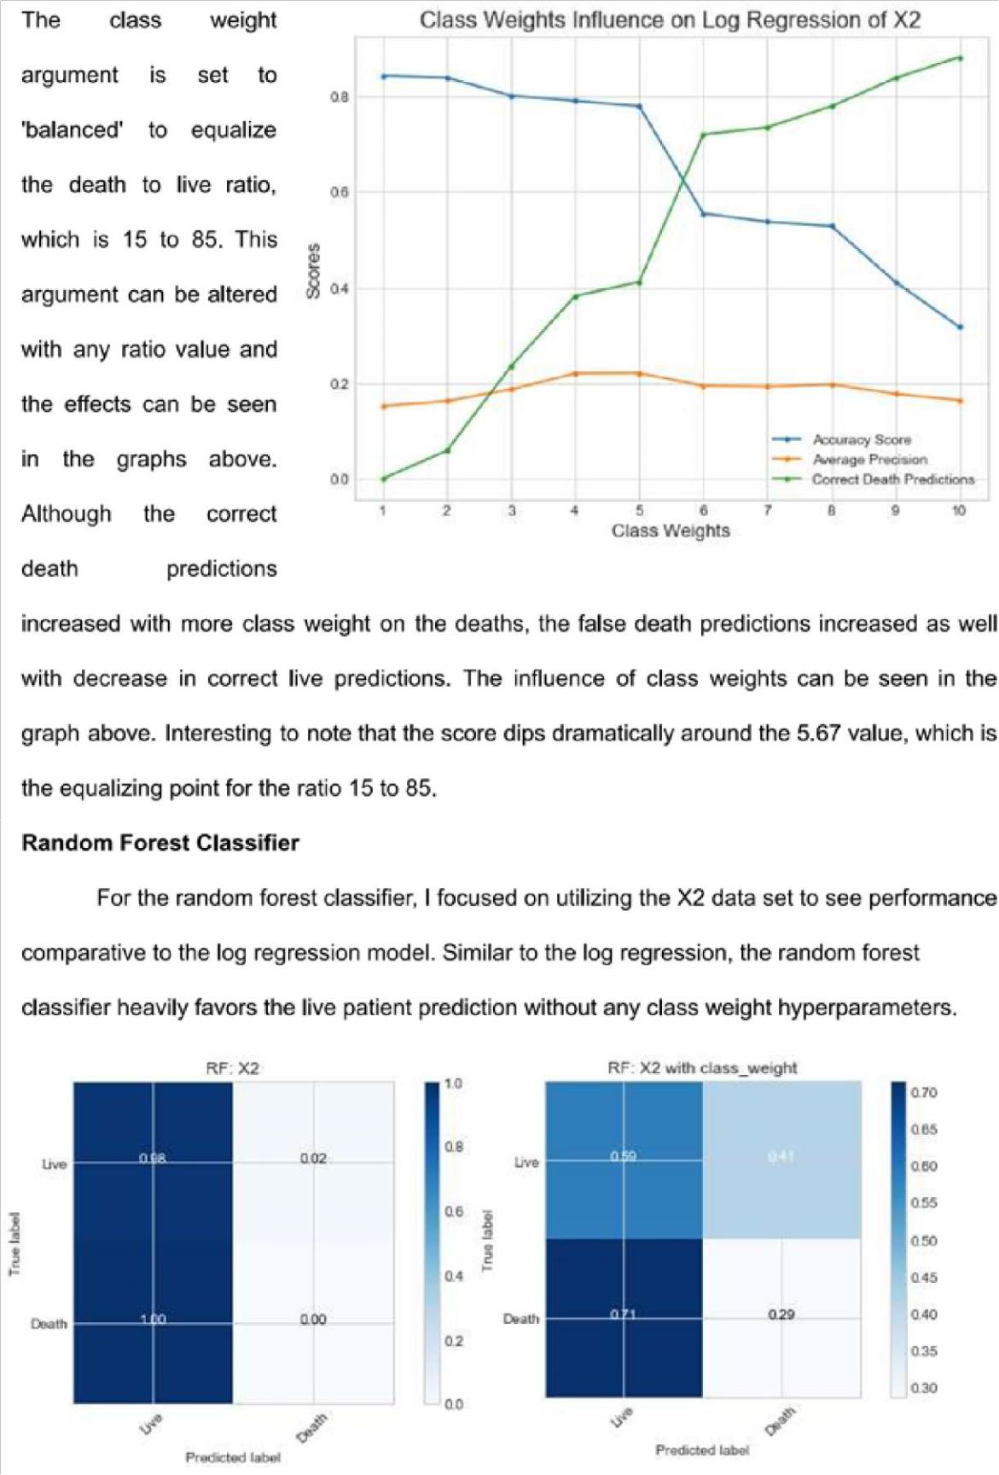

https://eu-

gb.dataplatform.cloud.ibm.com/data/jupyter2/runtimeenv2/v1/wdpx/service/notebook/conda2py361254feaf150945e6bd9168002d100682/d … 12/12
7/3/2020 ML
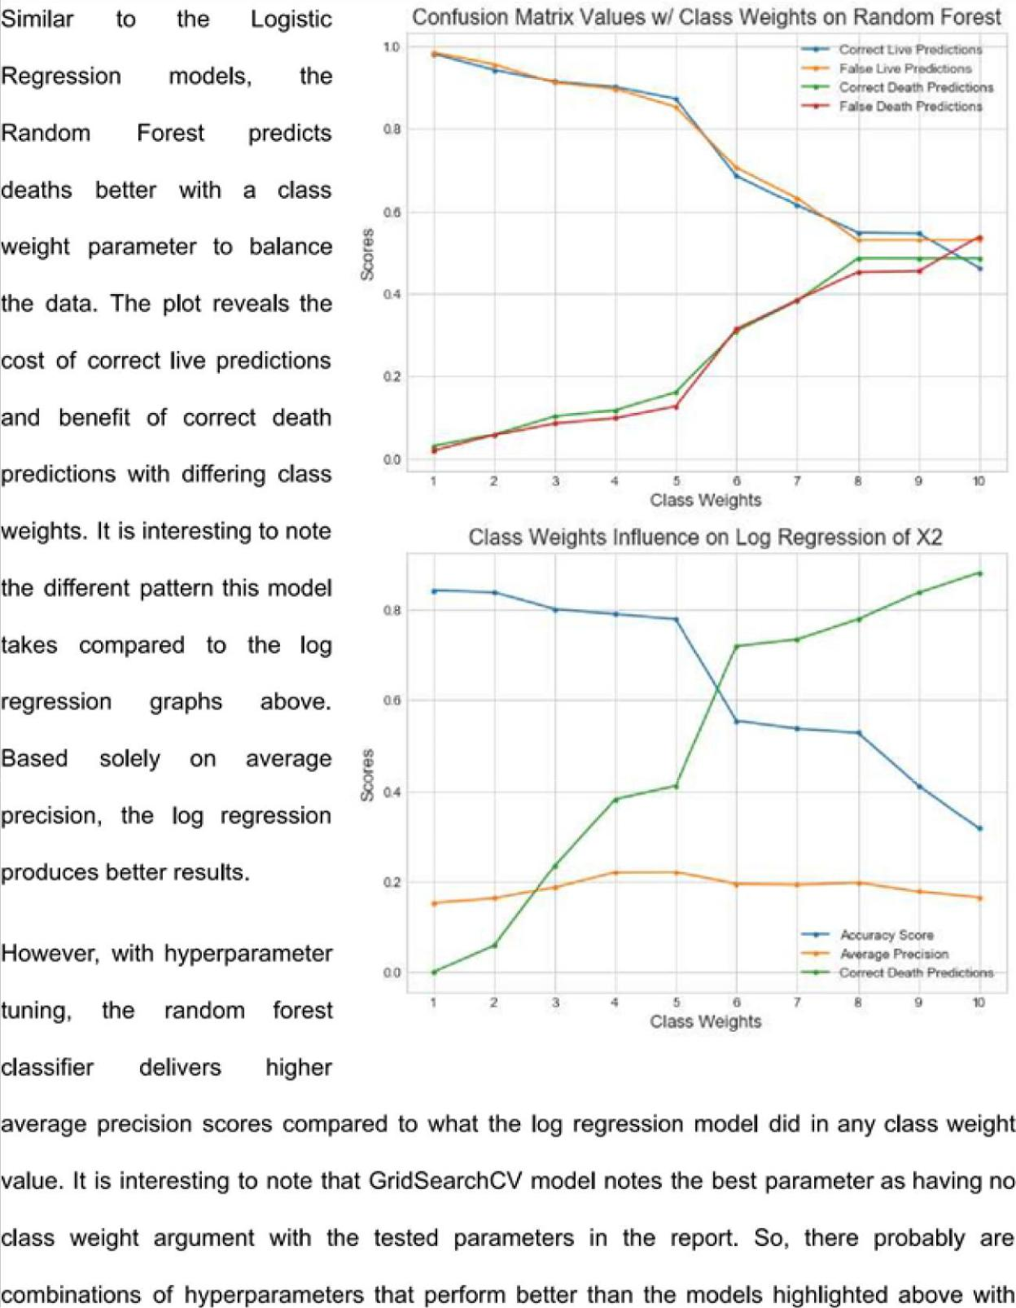

RESULT:

https://eu-

gb.dataplatform.cloud.ibm.com/data/jupyter2/runtimeenv2/v1/wdpx/service/notebook/conda2py361254feaf150945e6bd9168002d100682/d … 13/13
7/3/2020 ML
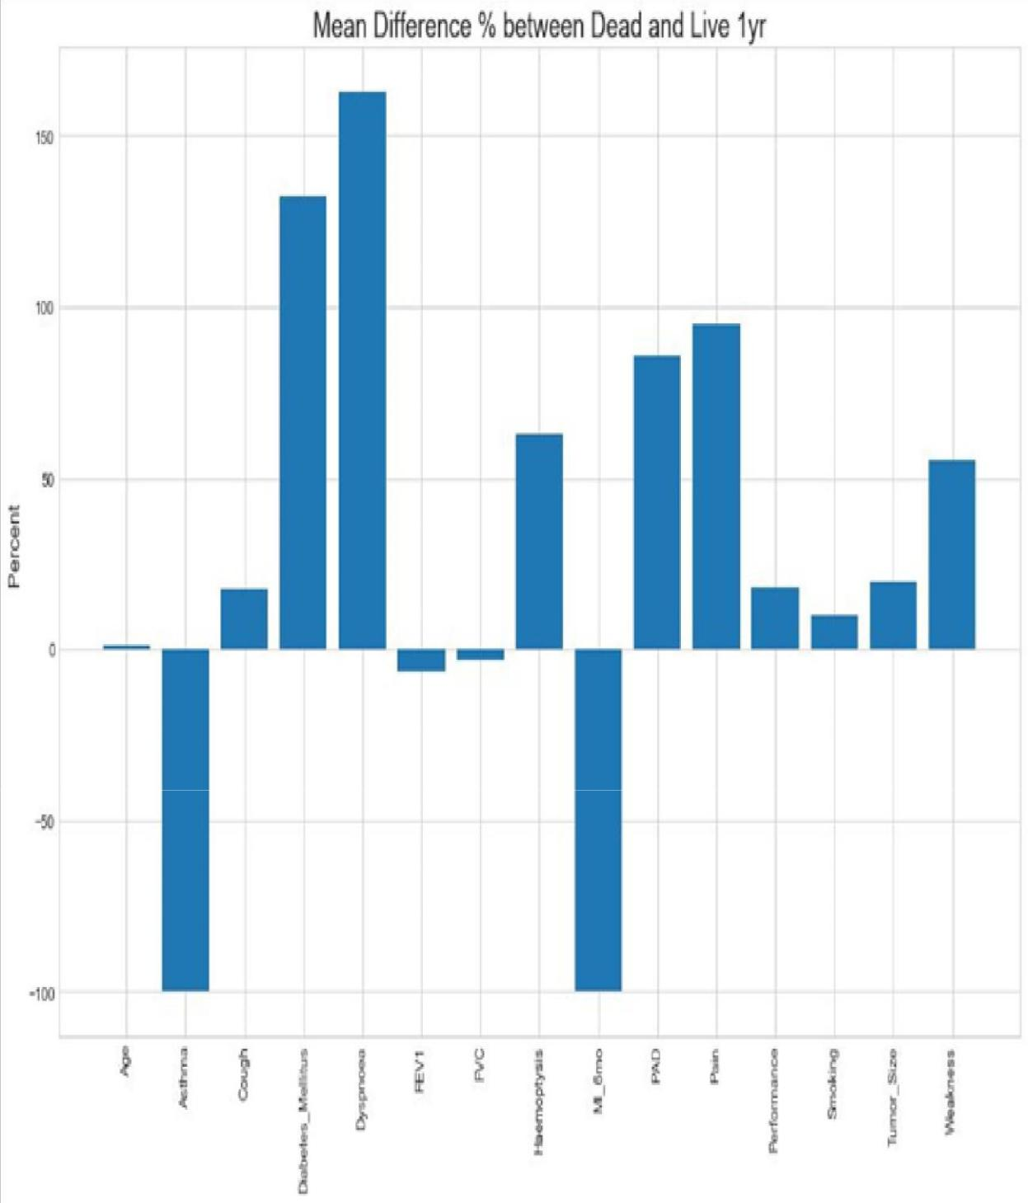

https://eu-

gb.dataplatform.cloud.ibm.com/data/jupyter2/runtimeenv2/v1/wdpx/service/notebook/conda2py361254feaf150945e6bd9168002d100682/d … 14/14
7/3/2020 ML
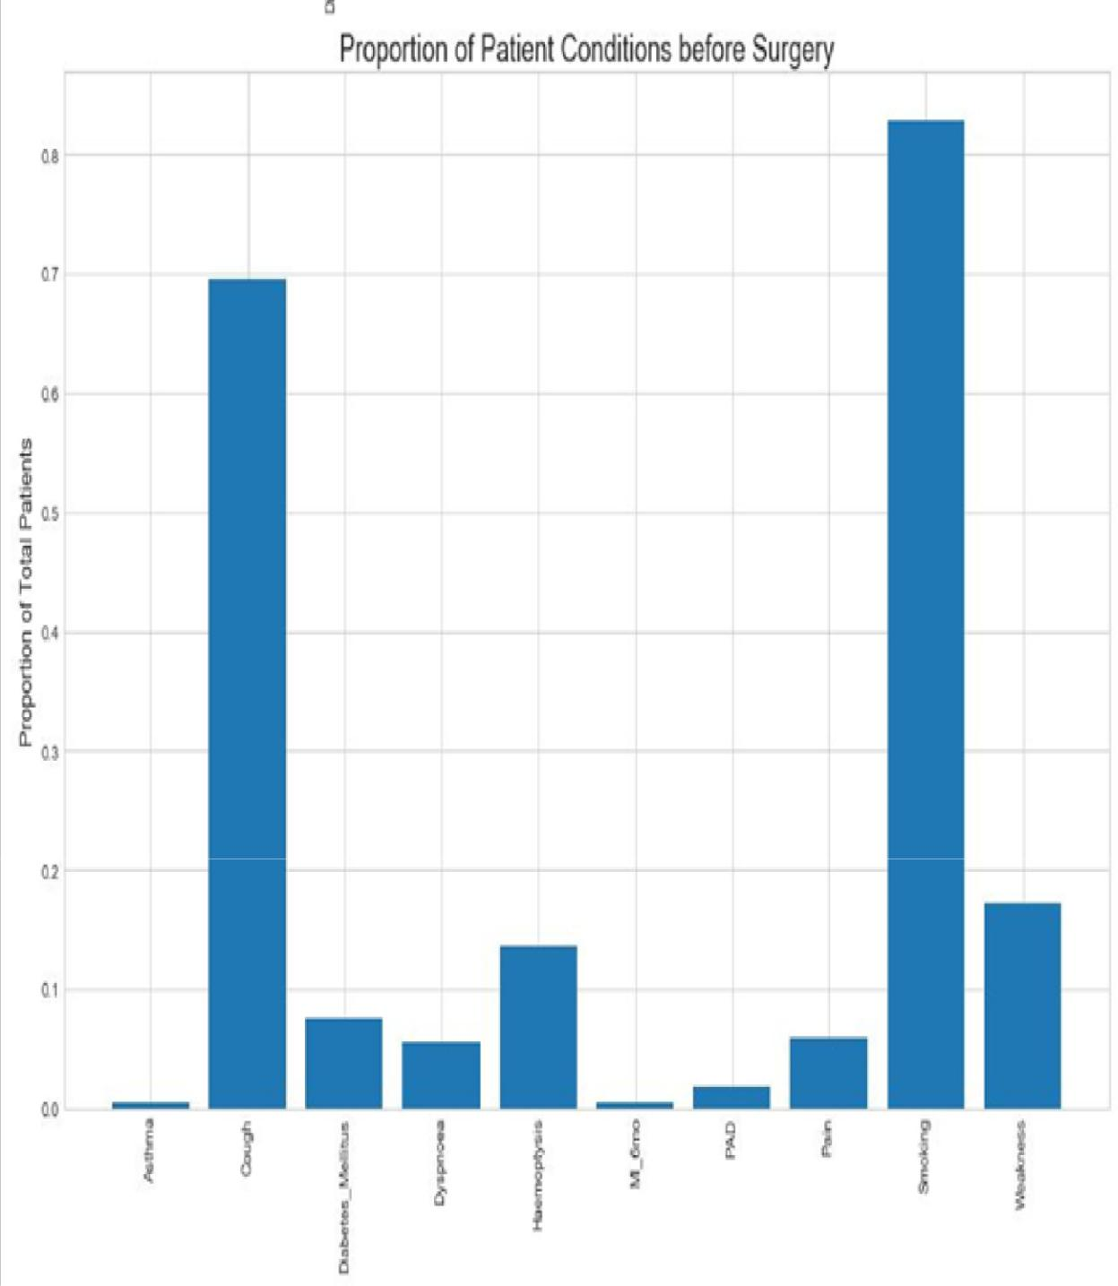

https://eu-

gb.dataplatform.cloud.ibm.com/data/jupyter2/runtimeenv2/v1/wdpx/service/notebook/conda2py361254feaf150945e6bd9168002d100682/d … 15/15
7/3/2020 ML
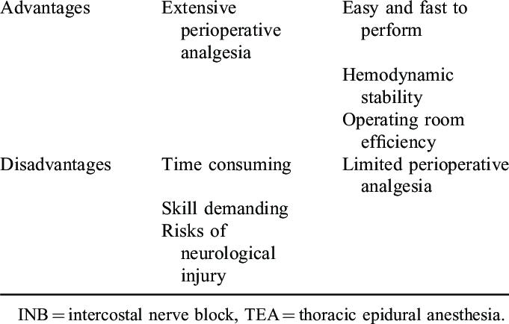

APPLICATIONS OF THOARAIC SURGERY:

Lymphatic mapping

Patients with Stage I lung cancer have a recurrence rate of nearly 40% and the overall 5-year survival rate is just 52% [ 12 ]. The high rate of disease recurrence suggests that these patients are frequently understaged and, subsequently, undertreated. By identifying lymph nodes at highest risk for tumour metastasis, SLN mapping helps identify patients who could benefit from adjuvant therapy. Several NP-based molecular imaging techniques have been explored for potential in the mapping of tumour-draining lymph nodes in human cancers [ 13 , 14 ]. Quantum dots (QDs) have been utilized as lymphatic mapping agents in a porcine model of non-small-cell lung cancer (NSCLC), with favourable properties including appropriate size for lymphatic migration and visible histological fluorescence (Fig. 1 ) [ 15 ]. More recently, superparamagnetic iron oxide (SPIO) NPs were coupled with magnetic resonance imaging (MRI) to create ultrasensitive nanoprobes for cellular and molecular imaging of various cancers. Notably, SPIO-enhanced MRI technology has been shown to detect tumour metastases in the SLNs of breast, bladder and prostate cancer patients [ 16 , 17 ]. In a 2011 study of 102 breast cancer patients with clinically negative axillary nodes, Motomura et al . [ 16 ] demonstrated that SPIO-enhanced MRI achieved almost 90% accuracy in the detection of SLN metastases. These promising results warrant the

https://eu-

gb.dataplatform.cloud.ibm.com/data/jupyter2/runtimeenv2/v1/wdpx/service/notebook/conda2py361254feaf150945e6bd9168002d100682/d … 16/16
7/3/2020 ML

upcoming investigation of SPIO-enhanced MR imaging as an SLN mapping strategy for lung and oesophageal cancer patients.

Image-guided nanosurgery

NP-based technologies possess several properties that enhance imaging of biological targets, including the ability to amplify contrast signal, unique physiochemical characteristics such as magnetic, thermal and pH-responsive phase changes, and the ability to modify pharmacokinetics via alterations in surface chemistry [ 10 ]. The development of targeted near-infrared fluorescent (NIRF) and surface-enhanced Raman scattering imaging probes for the evaluation of surgical margins and the real-time intraoperative identification of residual disease is a major focus of recent investigation. These technological advances have been translated to patient care with excellent initial results. Currently, NIRF-image-guided surgery utilizing 5-aminolevulinic acid (5-ALA) generates tumour fluorescence and better tumour visualization in patients with malignant glioma. 5-ALA precursor in the haemoglobin synthesis pathway elicits the accumulation of fluorescent porphyrins in various epithelia and cancerous tissues. Oral administration of 5-ALA leads to preferential accumulation of fluorescent porphyrins within glioma tissue, enabling more complete oncological resection and improved progression-free survival [ 24 ]. Ongoing research efforts are focused on the clinical translation of various Raman NPs that can be specifically utilized for NIRF imaging of various solid tumours, including lung cancer. It is anticipated that this technology will improve intraoperative guidance of surgical resection with negative margins in the future.

Several investigators have developed triple-modality NP imaging probes for use with a number of cancer imaging modalities, including PET, NIRF and MRI, to allow for preoperative tumour localization and surgical planning. One of the best characterized strategies utilizes MRI-photoacoustic silica-coated Raman NPs [ 25 ]. Kircher et al . reported the intravenous injection of Raman NPs into glioblastoma-bearing mice, which leads to intratumoural accumulation and retention for several days. Triple-modality MRI-based photoacoustic imaging was then used to guide intraoperative resection and accurately delineate tumour margins (Fig. 2 ) [ 25 ]. Ultra-sensitive Raman imaging can be utilized to detect and remove residual microscopic tumour burden. Coupling of high-resolution tissue-penetrating photoacoustic imaging and tumour-homing Raman NPs has potential to enable localization and accurate resection of non-palpable deep parenchymal lung lesions. Such approaches highlight the potential for translation of emerging nanotechnology platforms to thoracic surgery, particularly with the focus of enabling more accurate tumour imaging and improve oncological resection in patients with thoracic cancers

https://eu-

gb.dataplatform.cloud.ibm.com/data/jupyter2/runtimeenv2/v1/wdpx/service/notebook/conda2py361254feaf150945e6bd9168002d100682/d … 17/17
7/3/2020 ML

CONCLUSION :

Detection of lung cancer is one of the challenging problems in medical field due to structure of cancer cells, where most of the cells are overlapped to each other. Detection of lung cancer in the early stage is curable. The system contains two parts. One is Lung Cancer Detection part and the other is the Prediction of Life Expectancy Post Thoracic Surgery. Both the parts can run independently. The system is provided as a web application where anyone can upload a CT scan image of the lung in the front end and check out whether that image is infected with Lung Cancer. At the backend the image uploaded is preprocessed, segmented and predicted using the CNN model which is already trained. Also, the system provides a form requesting for the 14 attributes required to predict the survival span post Thoracic Surgery. Once the form is submitted, the form inputs are run on the LDA model and a response of whether the patient will survive or not is produced. CNN model used to detect lung cancer gave an accuracy of 95% and the LDA classifier gave the highest accuracy of 83.76% compared to other 3 algorithms used. The system considers only CT lung images as input, but further the system can be enhanced to take MRI (Magnetic Resonance Imaging) or PET (Position Emission Tomography) as input. Also, in the prediction of survival part, higher accuracies of the classifier can be achieved by considering large amount of dataset.

FUTURE SCOPE :

Thoracic surgery is living an enthusiastic era of thriving innovations. The changes in the fields of diagnostics, in the therapeutic options, the development of surgical techniques and the adoption of novel technologies has radically changed the horizons of our specialty. We must embrace the innovations, learn navigational bronchoscopy, understand the multiple targeted therapies, and learn new ways to operate on advanced cases. We will not be able to stay complacent with our current 3 ports video-assisted thoracoscopic surgery (VATS) technique with open instruments, therefore every surgeon needs to be watching for each latest development as it happens. In this brief manuscript we will summarize some of the most important development over the recent years and forecast how this will impact on the patients affected by thoracic malignancies. As thoracic surgeons we have to embraces these developments in order to redefine our specialty.

Bibliography

- Hendrix RJ, Lee C, Friedrich AK, Rouanet E, Larkin AC, LaFemina J. Prophylactic Versus Therapeutic Mastectomy: A Contemporary Analysis of the ACS-NSQIP Database. Clin Breast Cancer. 2019 Jun;19(3):e428-e432.

- Hendrix RJ, Martins PN, Stoff JS, Ahearn A, Bozorgzadeh A, Movahedi B. Successful Renal Transplantation after Presumed Cyanide Toxicity Treated with Hydroxocobalamin and Review of the Literature. Case Rep Transplant. 2018 Sep 9;2018:3753479.

- McKie K, McLoughlin RJ, Hirsh MP, Cleary MA, Aidlen JT. Risk Factors for Venous Thromboembolism in Children and Young Adults With Inflammatory Bowel Disease. J Surg Res. 2019 Jun 7;243:173-179.

- McLoughlin RJ, Green J, Nazarey PP, Hirsh MP, Cleary M, Aidlen JT. The risk of snow sport injury in pediatric patients. Am J Emerg Med. 2019 Mar;37(3):439-443.

- Hoang CM, Alavi K, Flahive JM, Sturrock PR, Maykel JA, Davids JS. Impact of the "Weekend Effect" for Hospital Discharges on Readmissions After Elective Colectomy. Dis Colon Rectum. 2019 Apr;62(4):476-482.

- Sarani B, Paspulati RM, Hambley J, Efron D, Martinez J, Perez A, Bowles-Cintron R, Yi F, Hill S, Meyer D, Maykel J, Attalla S, Kochman M, Steele S. A multidisciplinary approach to diagnosis and management of bowel obstruction.

https://eu-

gb.dataplatform.cloud.ibm.com/data/jupyter2/runtimeenv2/v1/wdpx/service/notebook/conda2py361254feaf150945e6bd9168002d100682/d … 18/18
7/3/2020 ML

- Curr Probl Surg. 2018 Oct;55(10):394-438.

- Davids JS, Lyu HG, Hoang CM, Daniel VT, Scully RE, Xu TY, Phatak UR, Damle A, Melnitchouk N. Female Representation and Implicit Gender Bias at the 2017 American Society of Colon and Rectal Surgeons' Annual Scientific and Tripartite Meeting. Dis Colon Rectum. 2019 Mar;62(3):357-362.

- Min M, Noujaim MG, Green J, Schlieve CR, Vaze A, Cahan MA, Cave DR. Role of Mucosal Protrusion Angle in Discriminating between True and False Masses of the Small Bowel on Video Capsule Endoscopy.

- J Clin Med. 2019 Mar 27;8(4). pii: E418.

- Murray CR, Balsam LB. Commentary: Outliers-Salvage operations and the Society of Thoracic

Surgeons risk model. J Thorac Cardiovasc Surg. 2019 Feb 27. pii: S0022-5223(19)30491
- Shahi N, Arosemena M, Kwon J, DiMuzio P, Abai B, Salvatore DM. A rare case of Clostridium septicum aortitis with colon adenocarcinoma. J Vasc Surg Cases Innov Tech. 2018 Apr 23;4(2):87-90.

- Hendrix RJ, Damle A, Williams C, Harris A, Spanakis S, Lambert DH, Lambert LA. Restrictive Intraoperative Fluid Therapy is Associated with Decreased Morbidity and Length of Stay Following Hyperthermic Intraperitoneal Chemoperfusion. Ann Surg Oncol. 2019 Feb;26(2):490-496.

SOURCE CODE:

%matplotlib inline

import pandas as pd import

numpy as np

import matplotlib.pyplot as plt import

seaborn as sns sns.set_style("whitegrid")

In [2]: import types import

pandas as pd

from botocore.client import Config
import ibm_boto3 def __iter__(self):

return 0

- @hidden_cell

- The following code accesses a file in your IBM Cloud Object Storage. It incl udes your credentials.

- You might want to remove those credentials before you share the notebook. client_ca664f4bd18b4ee7be1a254407d5a9cb = ibm_boto3.client(service_name='s3',

ibm_api_key_id='LnDsssRcQkVEuzSKFi8xiJ_iPDfljTBahv39piIi9d8c', ibm_auth_endpoint="https://iam.cloud.ibm.com/oidc/token", config=Config(signature_version='oauth'),

endpoint_url='https://s3.eu-geo.objectstorage.service.networklayer.com')

body = client_ca664f4bd18b4ee7be1a254407d5a9cb.get_object(Bucket='oneyearlifee xpectancypostthoracic-donotdelete-pr-ydkg5pb794dfn6',Key='Dataset.csv')['Body' ]

- add missing __iter__ method, so pandas accepts body as file-like object if not hasattr(body, "__iter__"): body.__iter__ = types.MethodType( __iter__, body )

Dataset = pd.read_csv(body) Dataset.head()

https://eu-

gb.dataplatform.cloud.ibm.com/data/jupyter2/runtimeenv2/v1/wdpx/service/notebook/conda2py361254feaf150945e6bd9168002d100682/d … 19/19
7/3/2020 ML

In [3]: Dataset . describe ()

Out[2]:

Diagnosis |  | FVC | FEV1 | Performance |  | Pain | Haemoptysis |  | Dyspnoea |  | Cough Weakness
 |  |  |  |  |  |  |  |  |  |  | Tumo
0 |  | 2 | 2.88 | 2.16 | 1 | 0 | 0 | 0 | 1 | 1
1 |  | 3 | 3.40 | 1.88 | 0 | 0 | 0 | 0 | 0 | 0
2 |  | 3 | 2.76 | 2.08 | 1 | 0 | 0 | 0 | 1 | 0
3 |  | 3 | 3.68 | 3.04 | 0 | 0 | 0 | 0 | 0 | 0
4 |  | 3 | 2.44 | 0.96 | 2 | 0 | 1 | 0 | 1 | 1

Out[3]:

 | Diagnosis |  | FVC | FEV1 | Performance |  | Pain | Haemoptysis | Dyspnoea
count | 454.000000 | 454.000000 | 454.00000 |  | 454.000000 | 454.000000 |  | 454.000000 | 454.000000 | 4
mean | 3.092511 | 3.287952 |  | 2.51685 | 0.795154 |  | 0.059471 | 0.136564 | 0.055066
std | 0.715817 | 0.872347 |  | 0.77189 | 0.531459 |  | 0.236766 | 0.343765 | 0.228361
min | 1.000000 | 1.440000 |  | 0.96000 | 0.000000 |  | 0.000000 | 0.000000 | 0.000000
25% | 3.000000 | 2.600000 |  | 1.96000 | 0.000000 |  | 0.000000 | 0.000000 | 0.000000
50% | 3.000000 | 3.160000 |  | 2.36000 | 1.000000 |  | 0.000000 | 0.000000 | 0.000000
75% | 3.000000 | 3.840000 |  | 2.97750 | 1.000000 |  | 0.000000 | 0.000000 | 0.000000
max | 8.000000 | 6.300000 |  | 5.48000 | 2.000000 |  | 1.000000 | 1.000000 | 1.000000

https://eu-

gb.dataplatform.cloud.ibm.com/data/jupyter2/runtimeenv2/v1/wdpx/service/notebook/conda2py361254feaf150945e6bd9168002d100682/d … 20/20
7/3/2020 ML


In [4]: # Stats for live and death after 1 yr patients live = Dataset[Dataset['Death_1yr'] == 0] death = Dataset[Dataset['Death_1yr'] == 1]

cond = ['FVC', 'FEV1', 'Performance', 'Pain', 'Haemoptysis', 'Dyspnoea', 'Coug h', 'Weakness',\ 'Tumor_Size', 'Diabetes_Mellitus', 'MI_6mo', 'PAD', 'Smoking', 'Asthm a', 'Age']

l = [np.mean(live[c]) for c in cond] d =
[np.mean(death[c]) for c in cond]

ld = pd.DataFrame(data={'Attribute': cond, 'Live 1yr Mean': l, 'Death 1yr Mea n': d})

ld = ld.set_index('Attribute')

print('Death: {:d}, Live: {:d}'.format(len(death), len(live)))

print("1 year death: {:.2f}% out of 454 patients".format(np.mean(Dataset.Death _1yr)*100)) ld

Death: 69, Live: 385

1 year death: 15.20% out of 454 patients

Out[4]:

 | Live 1yr Mean | Death 1yr Mean
Attribute
FVC | 3.304597 | 3.195072
FEV1 | 2.540805 | 2.383188
Performance | 0.774026 | 0.913043
Pain | 0.051948 | 0.101449
Haemoptysis | 0.124675 | 0.202899
Dyspnoea | 0.044156 | 0.115942
Cough | 0.677922 | 0.797101
Weakness | 0.158442 | 0.246377
Tumor_Size | 1.683117 | 2.014493
Diabetes_Mellitus | 0.062338 | 0.144928
MI_6mo | 0.005195 | 0.000000
PAD | 0.015584 | 0.028986
Smoking | 0.815584 | 0.898551
Asthma | 0.005195 | 0.000000
Age | 62.677922 | 63.333333

https://eu-

gb.dataplatform.cloud.ibm.com/data/jupyter2/runtimeenv2/v1/wdpx/service/notebook/conda2py361254feaf150945e6bd9168002d100682/d … 21/21
7/3/2020 ML
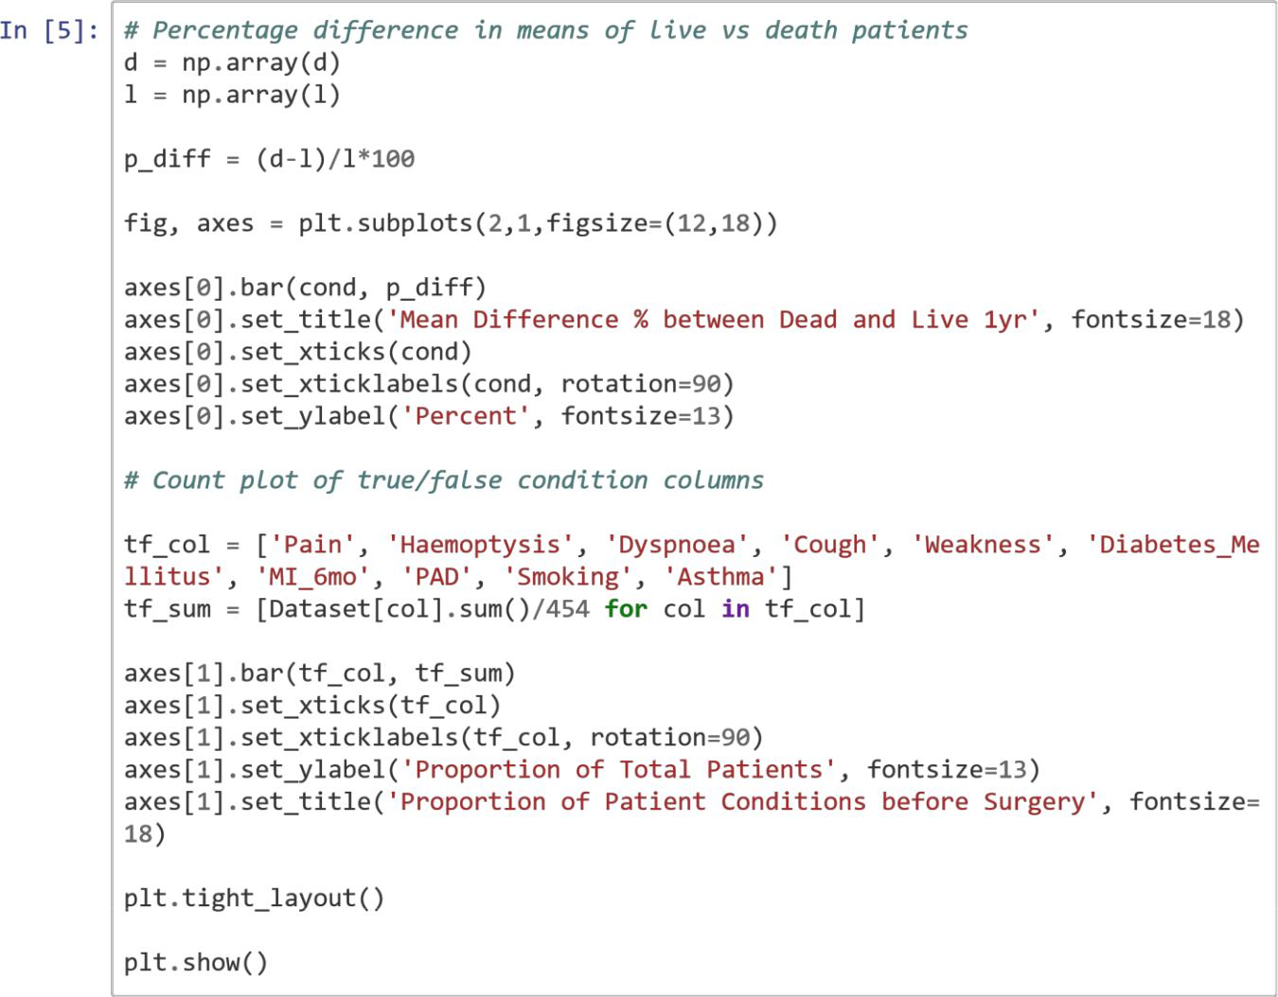

https://eu-

gb.dataplatform.cloud.ibm.com/data/jupyter2/runtimeenv2/v1/wdpx/service/notebook/conda2py361254feaf150945e6bd9168002d100682/d … 22/22
7/3/2020 ML
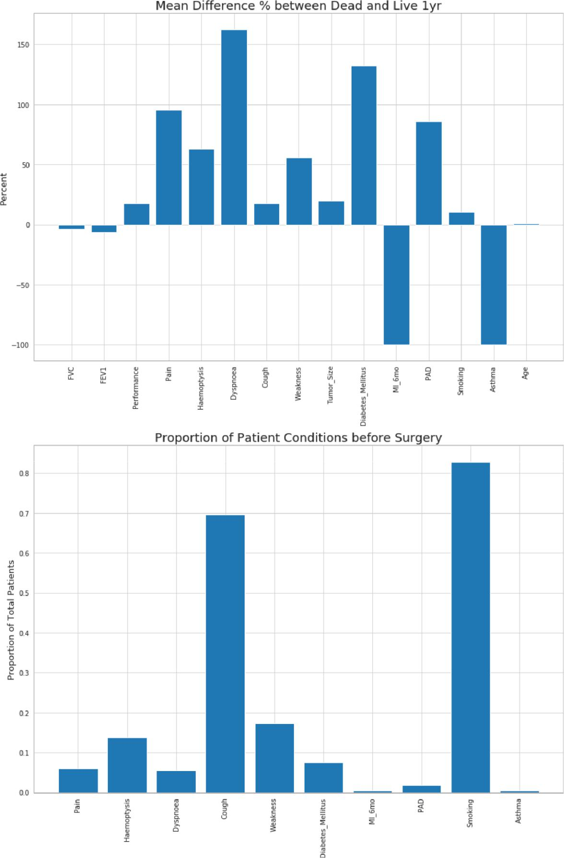

https://eu-

gb.dataplatform.cloud.ibm.com/data/jupyter2/runtimeenv2/v1/wdpx/service/notebook/conda2py361254feaf150945e6bd9168002d100682/d … 23/23
7/3/2020 ML


In [6]: # Count plots of Diagnosis, Tumor_Size, Performance with difference of live an d

death data fig, axes = plt.subplots(3,1,figsize=(10,15))

sns.countplot(x='Diagnosis', hue='Death_1yr', data=Dataset, palette='Blues_d', ax=axes[0]).set_title('Diagnosis', fontsize=18)

sns.countplot(x='Tumor_Size', hue='Death_1yr', data=Dataset, palette='Blues_d' , ax=axes[1]).set_title('Tumor_Size', fontsize=18)

sns.countplot(x='Performance', hue='Death_1yr', data=Dataset, palette='Blues_ d', ax=axes[2]).set_title('Performance', fontsize=18) plt.tight_layout()

https://eu-

gb.dataplatform.cloud.ibm.com/data/jupyter2/runtimeenv2/v1/wdpx/service/notebook/conda2py361254feaf150945e6bd9168002d100682/d … 24/24
7/3/2020 ML
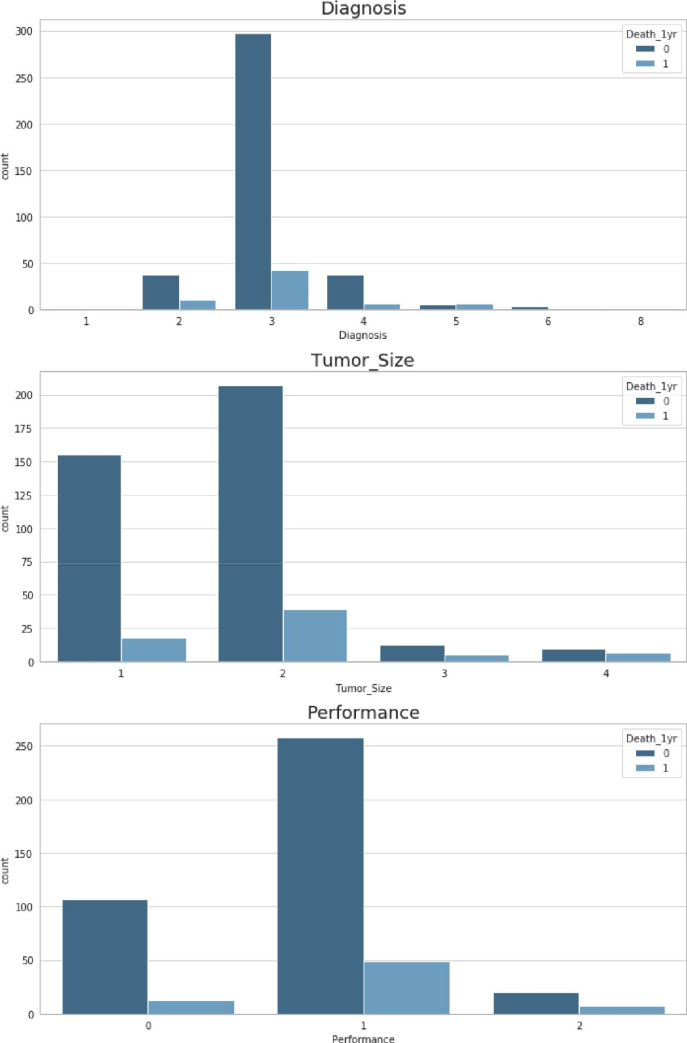

https://eu-

gb.dataplatform.cloud.ibm.com/data/jupyter2/runtimeenv2/v1/wdpx/service/notebook/conda2py361254feaf150945e6bd9168002d100682/d … 25/25
7/3/2020 ML


In [7]: def permutation_sample(data1, data2):

"""Generate a permutation data = np.concatenate((data1, np.random.permutation(data)

sample from two data sets.""" data2)) permuted_data =

perm_sample_1 = permuted_data[:len(data1)]

permuted_data[len(data1):] return

perm_sample_2 =

perm_sample_1,

perm_sample_2

def draw_perm_reps(data_1, data_2, func, size=1): """Generate multiple
permutation replicates.""" perm_replicates = np.empty(size)

for i in range(size): perm_sample_1, perm_sample_2 = permutation_sample(data_1,

data_2)

perm_replicates[i] = func(perm_sample_1, perm_sample_2)

return

perm_replicates

def diff_of_means(data_1, data_2):

"""Difference in means of two arrays.""" diff = np.mean(data_1) - np.mean(data_2) return diff

In [8]: # Hypothesis testing with Permutations of data condition = ['FVC', 'FEV1', 'Performance', 'Pain', 'Haemoptysis', 'Dyspnoea', 'Cough', 'Weakness',\

'Tumor_Size', 'Diabetes_Mellitus', 'MI_6mo', 'PAD', 'Smoking', 'A sthma', 'Age'] p_val = []


for c in condition: empirical_diff_means = diff_of_means(death[c], live[c]) perm_replicates = draw_perm_reps(death[c], live[c], diff_of_means, size=10

000) if empirical_diff_means > 0: p = np.sum(perm_replicates >= empirical_diff_means) / len(perm_replica

tes) p_val.append(p) else: p = np.sum(perm_replicates <= empirical_diff_means) / len(perm_replica

tes)

p_val.append(p) print(list(zip(condition, p_val)))

[('FVC', 0.1666), ('FEV1', 0.0567), ('Performance', 0.03), ('Pain', 0.0994),

('Haemoptysis', 0.0617), ('Dyspnoea', 0.023), ('Cough', 0.0259), ('Weakness', 0.0601), ( 'Tumor_Size', 0.0004), ('Diabetes_Mellitus', 0.0208), ('MI_6mo', 0. 7135) , ('PAD', 0.3571), ('Smoking', 0.0607), ('Asthma', 0.7213), ('Age', 0.27

25)]

https://eu-

gb.dataplatform.cloud.ibm.com/data/jupyter2/runtimeenv2/v1/wdpx/service/notebook/conda2py361254feaf150945e6bd9168002d100682/d … 26/26

7/3/2020 ML
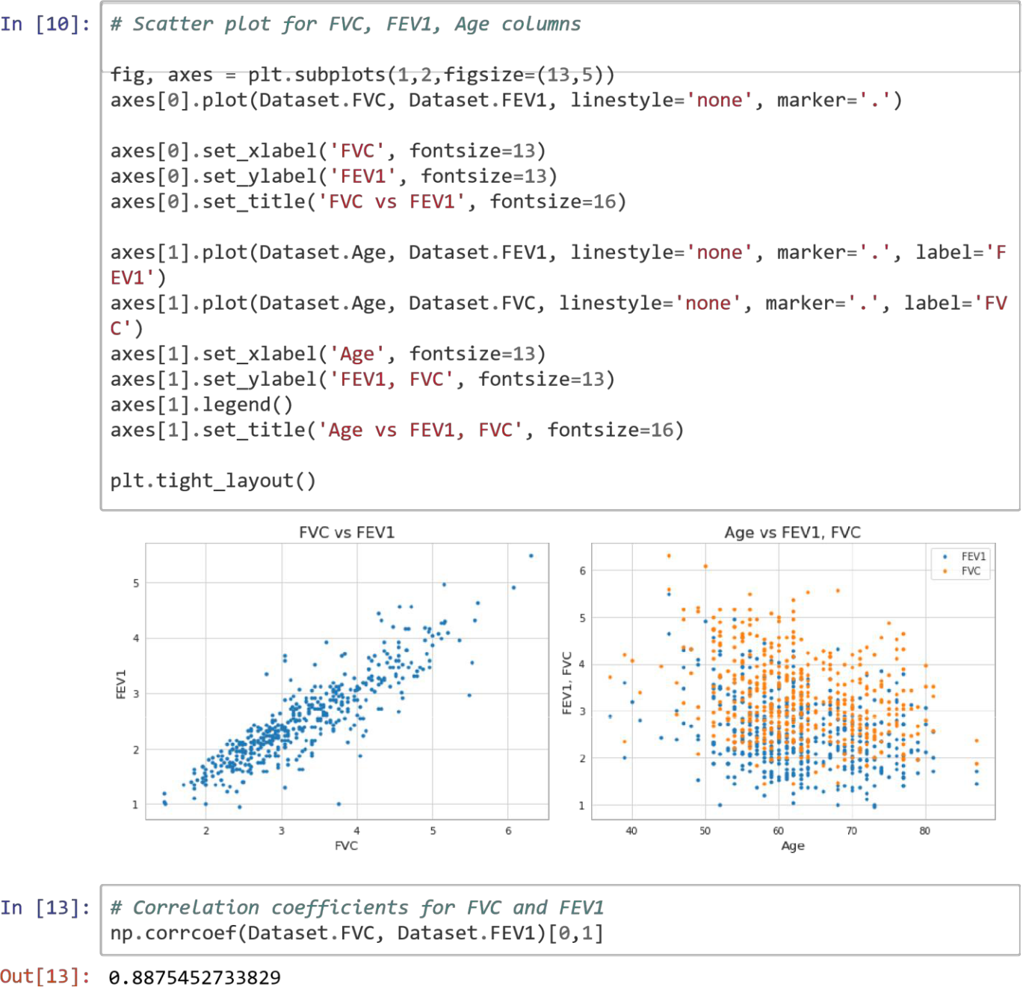

In [14]: # Correlation coefficients for Age and FVC np.corrcoef(Dataset.Age, Dataset.FVC)[0,1]

Out[14]: -0.299429919660491

In [15]: # Correlation coefficients for Age and FEV1 np.corrcoef(Dataset.Age,Dataset.FEV1)[0,1]

Out[15]: -0.3096166273079891

https://eu-

gb.dataplatform.cloud.ibm.com/data/jupyter2/runtimeenv2/v1/wdpx/service/notebook/conda2py361254feaf150945e6bd9168002d100682/d … 27/27
7/3/2020 ML
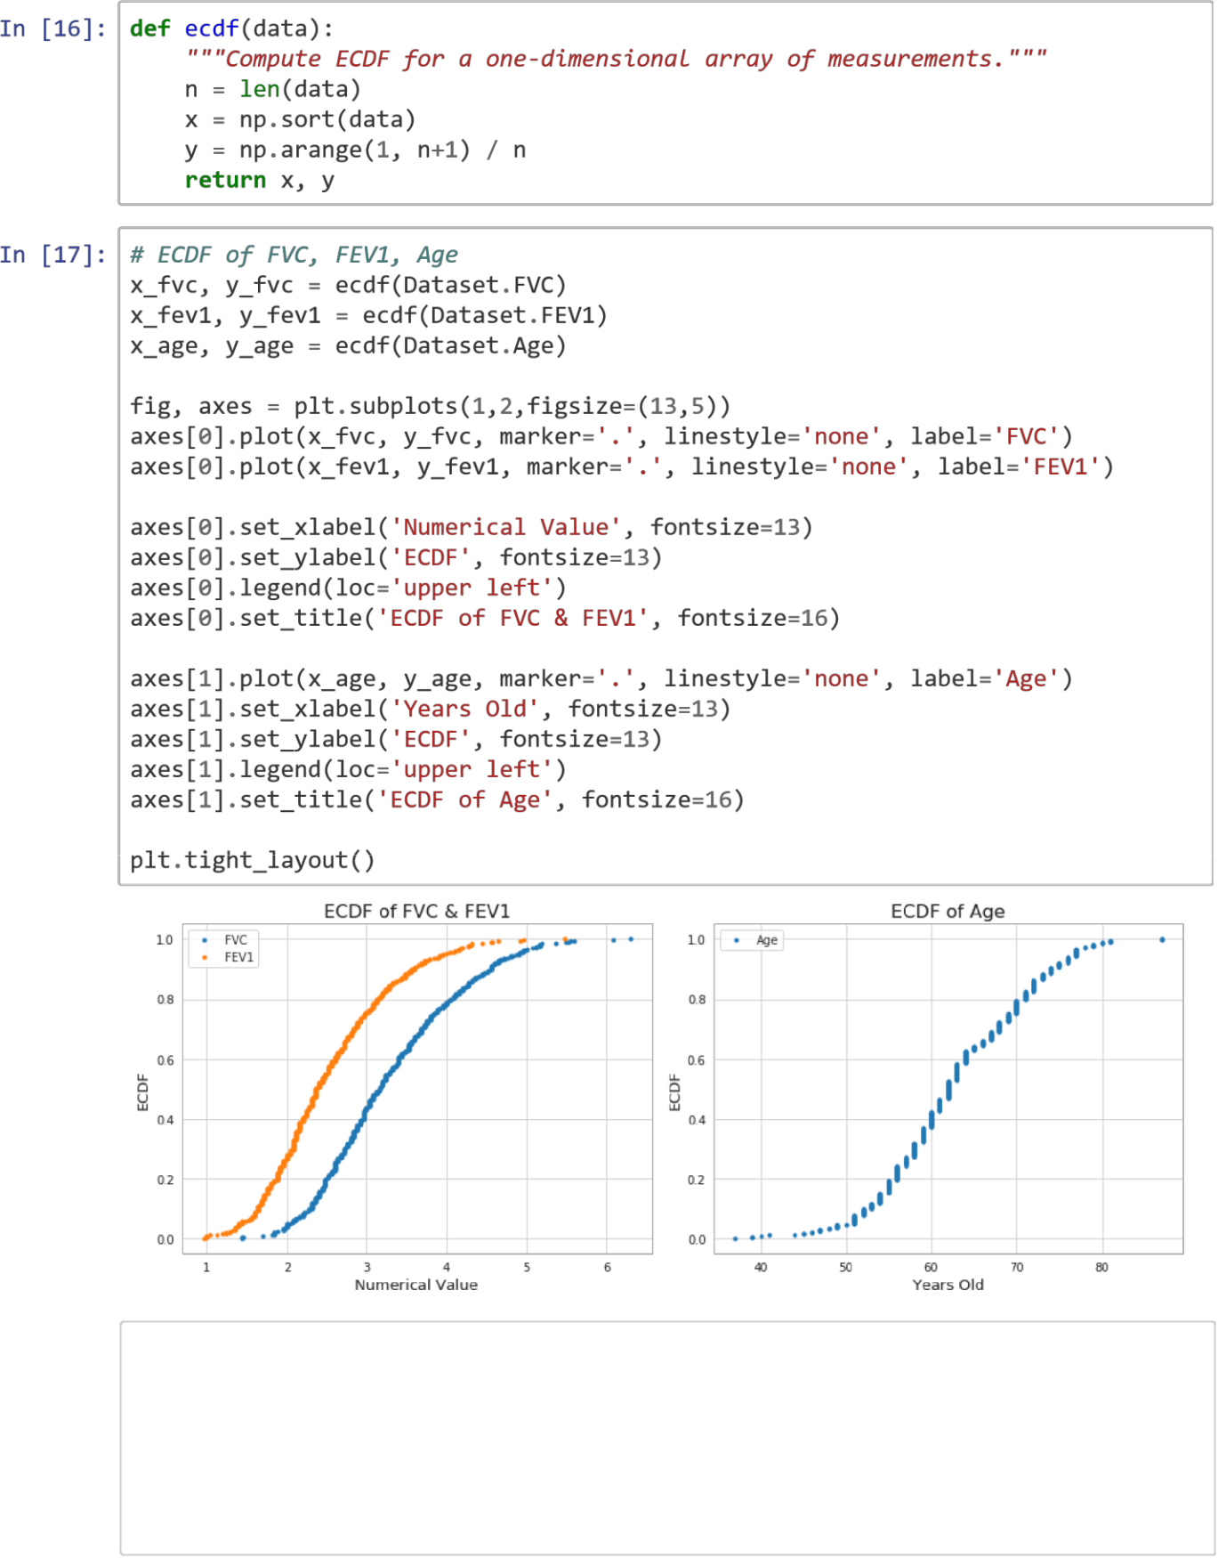

In [18]: from sklearn.linear_model import LogisticRegression from sklearn.model_selection import cross_val_score, cross_val_predict, train_ test_split, GridSearchCV

from sklearn.metrics import confusion_matrix, classification_report, accuracy_ score, average_precision_score

from sklearn.ensemble import RandomForestClassifier import itertools

https://eu-
gb.dataplatform.cloud.ibm.com/data/jupyter2/runtimeenv2/v1/wdpx/service/notebook/conda2py361254feaf150945e6bd9168002d10

0682/d… 28/28
7/3/2020 ML


In [20]: # All attributes excluding target variable, Asthma, and MI_6mo

- = Dataset.drop(['Death_1yr', 'MI_6mo', 'Asthma'], axis=1)

  - Attributes of Significance from Hypothesis Testing
X2 = Dataset[['Performance', 'Dyspnoea', 'Cough', 'Tumor_Size', 'Diabetes_Mell itus']] y = Dataset['Death_1yr']

In [21]:

def plot_confusion_matrix(cm, cmap=plt.cm.Blues):

classes,

normalize=False, title='Confusion


matri

x',

"""

This function prints and plots the confusion matrix.

Normalization can be applied by setting `normalize=True`.
""" if normalize: cm = cm.astype('float') / cm.sum(axis=1)[:,

np.newaxis] print("Normalized confusion matrix") else:

print('Confusion matrix') print(cm)

plt.imshow(cm, interpolation='nearest', cmap=cmap)
plt.title(title) plt.colorbar()
tick_marks = np.arange(len(classes)) plt.xticks(tick_marks, classes,

rotation=45) plt.yticks(tick_marks, classes)

fmt = '.2f' if normalize else 'd' thresh = cm.max() / 2.
itertools.product(range(cm.shape[0]), range(cm.shape[1])):

for i, j plt.text(j,

in
i,

format(cm[i, j], fmt), horizontalalignment="center",

color="white" if cm[i, j] > thresh else "black")

plt.tight_layout() plt.ylabel('True
label') plt.xlabel('Predicted label') In
[22]: def model_report(model, X, y,
title, weight=None):

"""Takes in classifier model with X data and class weight to display score s and confusion matrix."""

X_train, X_test, y_train, y_test = train_test_split(X, y, test_size=.3, ra ndom_state=1111, stratify=y)

clf = model(class_weight=weight, random_state=1111)

clf.fit(X_train, y_train)
clf.predict(X_test)

y_pred =

class_names = ['Live', 'Death']

print('Accuracy: {:.2f}'.format(accuracy_score(y_test, y_pred)))
Precision: {:.2f}'.format(average_precision_score(y_test, y

print('Average

_pred))) print(classification_report(y_test, y_pred, target_names=class_names))

cnf_matrix = confusion_matrix(y_test, y_pred) np.set_printoptions(precision=2)

https://eu-

gb.dataplatform.cloud.ibm.com/data/jupyter2/runtimeenv2/v1/wdpx/service/notebook/conda2py361254feaf150945e6bd9168002d10

0682/d… 29/29

7/3/2020 ML

# Plot confusion matrix
plt.figure()

plot_confusion_matrix(cnf_matrix, classes=class_names, normalize=True, tit le=title)

plt.show()

https://eu-

gb.dataplatform.cloud.ibm.com/data/jupyter2/runtimeenv2/v1/wdpx/service/notebook/conda2py361254feaf150945e6bd9168002d10

0682/d… 30/30
7/3/2020 ML


In [23]: def class_weights_plot(model, title):

"""Plots accuracy, average precision, and correct death predictions of dif ferent class weights for X2 data."""
class_weights = [1,2,3,4,5,6,7,8,9,10]
acc_scores = [] prec_scores = []

correct_deaths = []

for cw in class_weights: clf = model(class_weight={0: 1, 1: cw}, random_state=1111) predicted = cross_val_predict(clf, X2, y, cv=5)

acc_scores.append(accuracy_score(y, predicted))
prec_scores.append(average_precision_score(y, predicted))
correct_deaths.append(confusion_matrix(y, predicted)[1,1]/68)

plt.figure(figsize=(8,6))

plt.plot(class_weights, acc_scores, marker='.', label='Accuracy Score') plt.plot(class_weights, prec_scores, marker='.', label='Average Precision'

) plt.plot(class_weights, correct_deaths, marker='.', label='Correct Death P redictions')
plt.xticks(class_weights)
plt.xlabel('Class Weights', fontsize=13)
plt.ylabel('Scores', fontsize=13) plt.legend()

plt.title(title, fontsize=16) plt.show()

In [24]: def class_weights_tf_plot(model, title):

"""Plots confusion matrix values of different class weights for X2 dat

a."""
class_weights = [1,2,3,4,5,6,7,8,9,10]
true_live = [] false_live = [] true_death = []

false_death = []

for cw in class_weights: clf = model(class_weight={0: 1, 1: cw}, random_state=1111) predicted = cross_val_predict(clf, X2, y, cv=5)

true_live.append(confusion_matrix(y, predicted)[0,0]/385)
false_live.append(confusion_matrix(y, predicted)[1,0]/68)
true_death.append(confusion_matrix(y, predicted)[1,1]/68)

false_death.append(confusion_matrix(y, predicted)[0,1]/385)

plt.figure(figsize=(8,6))

plt.plot(class_weights, true_live, marker='.', label='Correct Live Predict

ions') plt.plot(class_weights, false_live, marker='.', label='False Live Predicti
ons')

plt.plot(class_weights, true_death, marker='.', label='Correct Death Predi

ctions') plt.plot(class_weights, false_death, marker='.', label='False Death Predic
tions')

plt.xticks(class_weights)
plt.xlabel('Class Weights', fontsize=13)

plt.ylabel('Scores', fontsize=13) plt.legend()

plt.title(title, fontsize=16) plt.show()

https://eu-
gb.dataplatform.cloud.ibm.com/data/jupyter2/runtimeenv2/v1/wdpx/service/notebook/conda2py361254feaf150945e6bd9168002d10

0682/d… 31/31
7/3/2020 ML

In [25]: # Log Reg on X with no class weights model_report(LogisticRegression,
X, y,'LogReg: X')

/opt/conda/envs/Python36/lib/python3.6/site-packages/sklearn/linear_model/log istic.py:433: FutureWarning: Default solver will be changed to 'lbfgs' in 0.2 2. Specify a solver to silence this warning. FutureWarning)

/opt/conda/envs/Python36/lib/python3.6/site-packages/sklearn/metrics/classifi cation.py:1143: UndefinedMetricWarning: Precision and F -score are ill-defined and being set to 0.0 in labels with no predicted samples. 'precision', 'predicted', average, warn_for)

/opt/conda/envs/Python36/lib/python3.6/site-packages/sklearn/metrics/classifi cation.py:1143: UndefinedMetricWarning: Precision and F -score are ill-defined and being set to 0.0 in labels with no predicted samples. 'precision', 'predicted', average, warn_for)

/opt/conda/envs/Python36/lib/python3.6/site-packages/sklearn/metrics/classifi cation.py:1143: UndefinedMetricWarning: Precision and F -score are ill-defined and being set to 0.0 in labels with no predicted samples. 'precision', 'predicted', average, warn_for)

Accuracy: 0.85

Average Precision: 0.15 precision recall f1-score support

Live 0.85 1.00 0.92 116 Death 0.00 0.00 0.00
21
micro avg 0.85 0.85 | 0.85 | 137 | macro avg 0.42 0.50
0.46 137 weighted avg | 0.72 | 0.85 | 0.78 137

Normalized confusion matrix

[[1. 0.]

[1. 0.]]
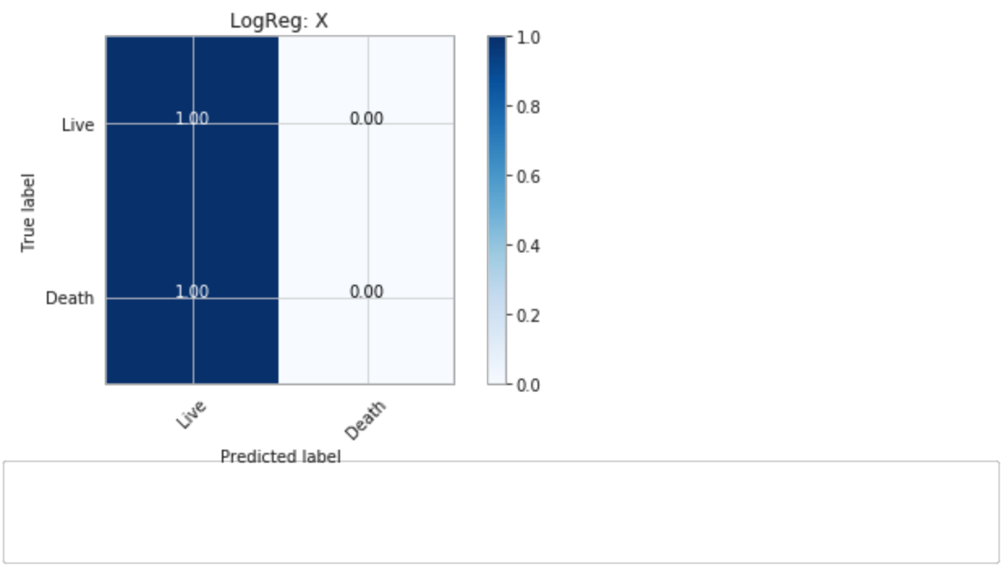

In [26]: # Log Reg on X with class weight balanced since imbalanced death numbers
(15%) model_report(LogisticRegression, X, y,'LogReg: X with class_weight','balanced' )

/opt/conda/envs/Python36/lib/python3.6/site-packages/sklearn/linear_model/log istic.py:433: FutureWarning: Default solver will be changed to 'lbfgs' in 0.2 2. Specify a solver to silence this warning. FutureWarning)

https://eu-
gb.dataplatform.cloud.ibm.com/data/jupyter2/runtimeenv2/v1/wdpx/service/notebook/conda2py361254feaf150945e6bd9168002d10

0682/d… 32/32
7/3/2020 ML

Accuracy: 0.65

Average Precision: 0.18 precision recall f1-score support

Live 0.88 0.68 0.77 116 Death 0.21 0.48 0.29
21
micro avg 0.65 0.65 | 0.65 | 137 | macro avg 0.55 0.58
0.53 137 weighted avg | 0.78 | 0.65 | 0.69 137

Normalized confusion matrix

[[0.68 0.32]

[0.52 0.48]]
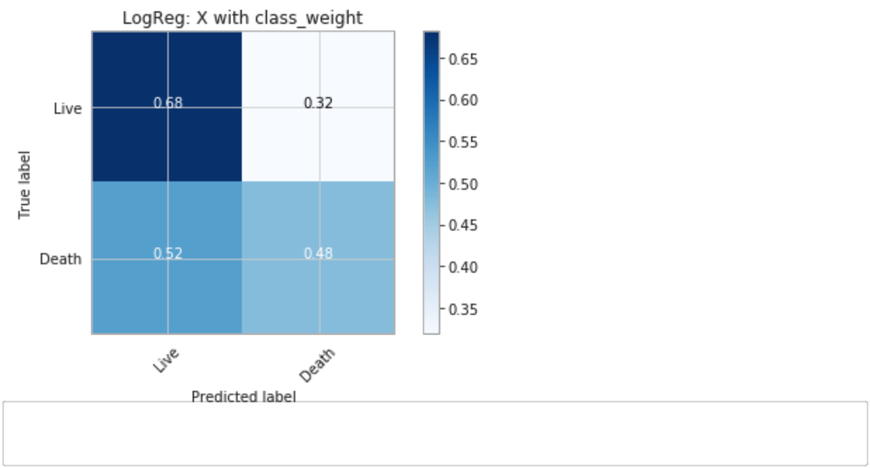

In [27]: # X2 log reg with no class weights model_report(LogisticRegression,
X2, y,'LogReg: X2')

/opt/conda/envs/Python36/lib/python3.6/site-packages/sklearn/linear_model/log istic.py:433: FutureWarning: Default solver will be changed to 'lbfgs' in 0.2 2. Specify a solver to silence this warning. FutureWarning)

/opt/conda/envs/Python36/lib/python3.6/site-packages/sklearn/metrics/classifi cation.py:1143: UndefinedMetricWarning: Precision and F -score are ill-defined and being set to 0.0 in labels with no predicted samples. 'precision', 'predicted', average, warn_for)

/opt/conda/envs/Python36/lib/python3.6/site-packages/sklearn/metrics/classifi cation.py:1143: UndefinedMetricWarning: Precision and F -score are ill-defined and being set to 0.0 in labels with no predicted samples. 'precision', 'predicted', average, warn_for)

/opt/conda/envs/Python36/lib/python3.6/site-packages/sklearn/metrics/classifi cation.py:1143: UndefinedMetricWarning: Precision and F -score are ill-defined and being set to 0.0 in labels with no predicted samples. 'precision', 'predicted', average, warn_for)

Accuracy: 0.85

Average Precision: 0.15 precision recall f1-score support

Live 0.85 1.00 0.92 116 Death 0.00 0.00 0.00
21

https://eu-

gb.dataplatform.cloud.ibm.com/data/jupyter2/runtimeenv2/v1/wdpx/service/notebook/conda2py361254feaf150945e6bd9168002d10

0682/d… 33/33
7/3/2020 ML

micro avg 0.85 0.85 | 0.85 | 137 | macro avg 0.42 0.50
0.46 137 weighted avg | 0.72 | 0.85 | 0.78 137

Normalized confusion matrix

[[1. 0.]

[1. 0.]]
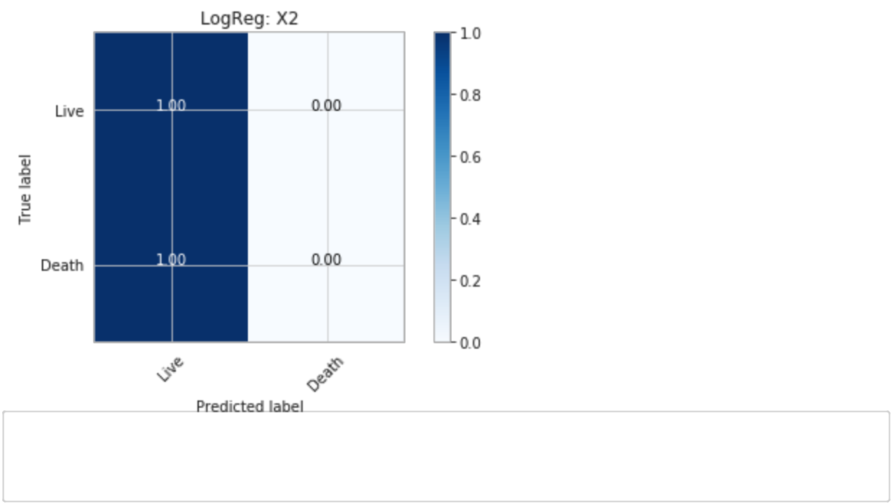

In [28]: # X2 log reg with class weight balanced model_report(LogisticRegression, X2,
y,'LogReg: X2 with class_weight','balance d')

/opt/conda/envs/Python36/lib/python3.6/site-packages/sklearn/linear_model/log istic.py:433: FutureWarning: Default solver will be changed to 'lbfgs' in 0.2 2. Specify a solver to silence this warning. FutureWarning)

Accuracy: 0.57

Average Precision: 0.20 precision recall f1-score support

Live 0.91 0.54 0.68 116 Death 0.22 0.71 0.34
21
micro avg 0.57 0.57 | 0.57 | 137 | macro avg 0.57 0.63
0.51 137 weighted avg | 0.81 | 0.57 | 0.63 137

Normalized confusion matrix

[[0.54 0.46]

[0.29 0.71]]

https://eu-

gb.dataplatform.cloud.ibm.com/data/jupyter2/runtimeenv2/v1/wdpx/service/notebook/conda2py361254feaf150945e6bd9168002d10

0682/d… 34/34
7/3/2020 ML
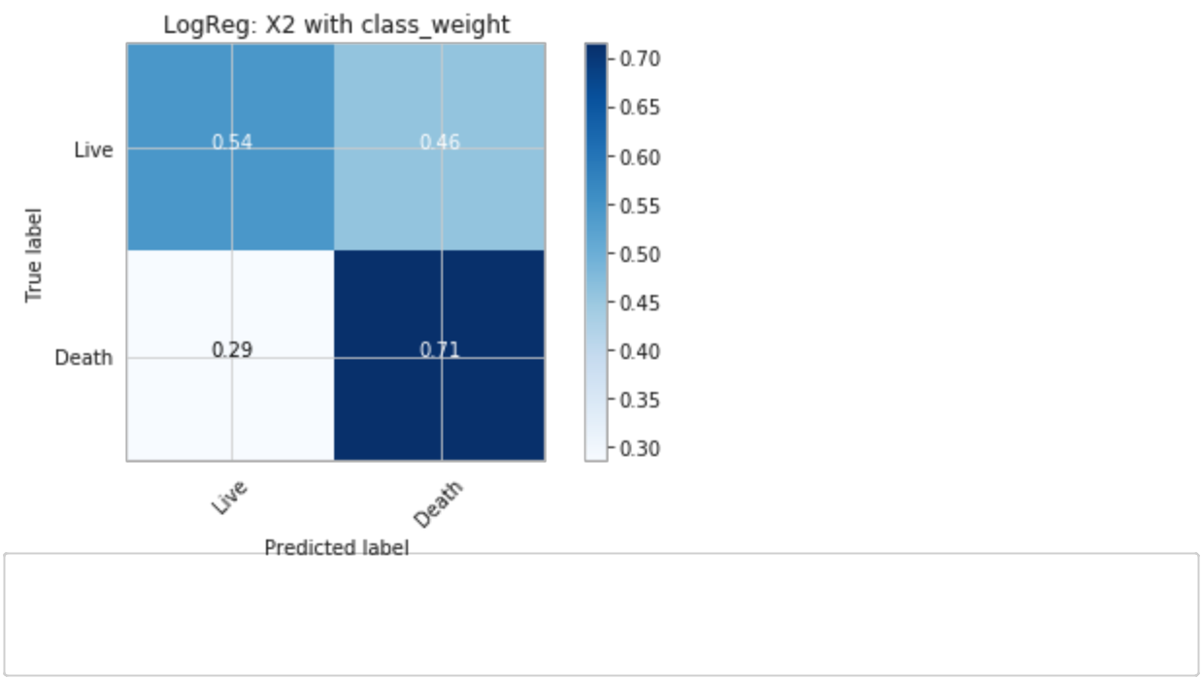

In [29]: # Plot different class weights influence on Log Reg X2
class_weights_tf_plot(LogisticRegression, 'Confusion Matrix Values w/ Class We ights on Log Regression')

https://eu-
gb.dataplatform.cloud.ibm.com/data/jupyter2/runtimeenv2/v1/wdpx/service/notebook/conda2py361254feaf150945e6bd9168002d10

0682/d… 35/35
7/3/2020 ML
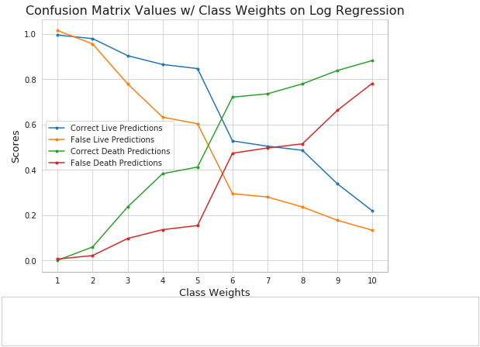

In [30]: # Plot different class weights influence on LogReg X2

class_weights_plot(LogisticRegression, 'Class Weights Influence on Log Regress ion of X2')

https://eu-
gb.dataplatform.cloud.ibm.com/data/jupyter2/runtimeenv2/v1/wdpx/service/notebook/conda2py361254feaf150945e6bd9168002d10

0682/d… 36/36
7/3/2020 ML

FutureWarning)
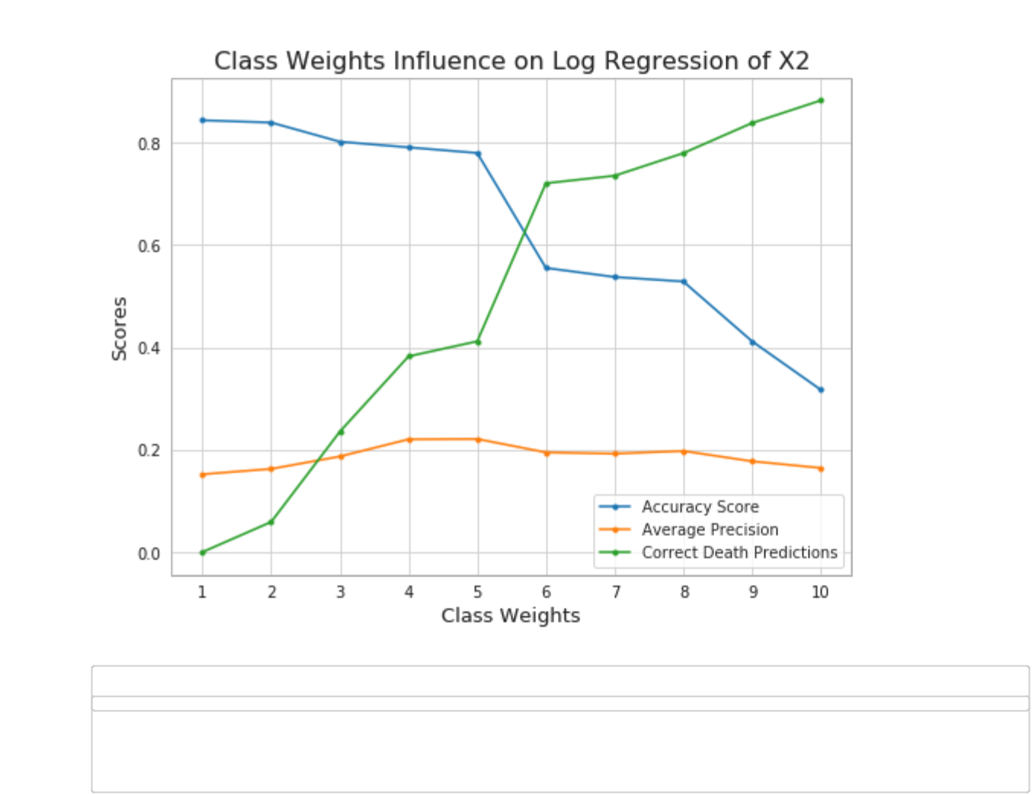

In [ ]: #Random forest classifier

In [31]: # X2 Random Forest Classifier with equal class weights 1:1

model_report(RandomForestClassifier, X2, y,'RF: X2')

/opt/conda/envs/Python36/lib/python3.6/site-packages/sklearn/ensemble/forest. py:246: FutureWarning:
The default value of n_estimators will change from 10 in version 0.20 to 100 in 0.22.

"10 in version 0.20 to 100 in 0.22.", FutureWarning)

Accuracy: 0.83

Average Precision: 0.15 precision recall f1-score support

Live 0.84 0.98 0.91 116 Death 0.00 0.00 0.00
21
micro avg 0.83 0.83 | 0.83 | 137 | macro avg 0.42 0.49
0.45 137 weighted avg | 0.72 | 0.83 | 0.77 137

Normalized confusion matrix

[[0.98 0.02]

[1. 0. ]]

https://eu-
gb.dataplatform.cloud.ibm.com/data/jupyter2/runtimeenv2/v1/wdpx/service/notebook/conda2py361254feaf150945e6bd9168002d10

0682/d… 37/37
7/3/2020 ML
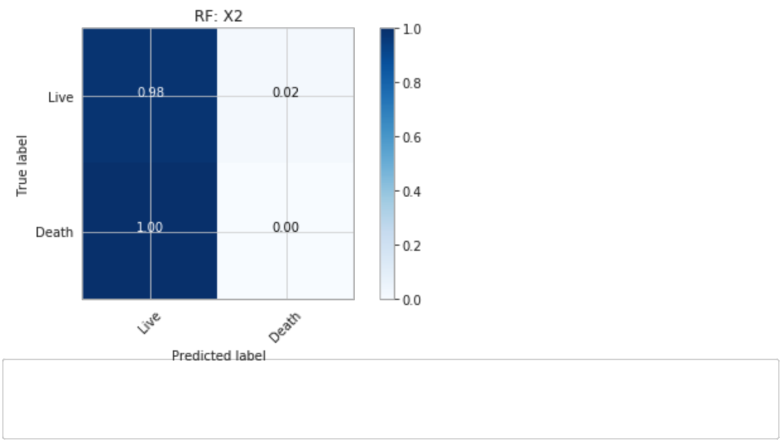

In [32]: # X2 Random Forest Classifier with class weight 5.67

model_report(RandomForestClassifier, X2, y, 'RF: X2 with class_weight','balanc ed')

/opt/conda/envs/Python36/lib/python3.6/site-packages/sklearn/ensemble/forest. py:246: FutureWarning:
The default value of n_estimators will change from 10 in version 0.20 to 100 in 0.22.

"10 in version 0.20 to 100 in 0.22.", FutureWarning)

Accuracy: 0.54

Average Precision: 0.14 precision recall f1-score support

Live 0.82 0.59 0.68 116 Death 0.11 0.29 0.16
21
micro avg 0.54 0.54 | 0.54 | 137 | macro avg 0.47 0.44
0.42 137 weighted avg | 0.71 | 0.54 | 0.60 137

Normalized confusion matrix

[[0.59 0.41]

[0.71 0.29]]

https://eu-
gb.dataplatform.cloud.ibm.com/data/jupyter2/runtimeenv2/v1/wdpx/service/notebook/conda2py361254feaf150945e6bd9168002d10

0682/d… 38/38
7/3/2020 ML
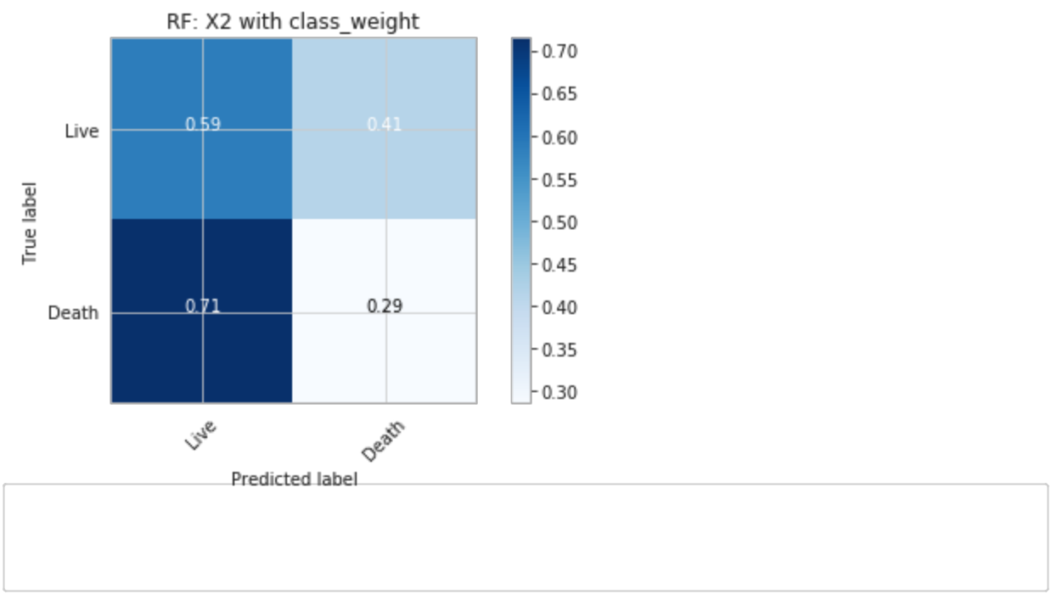

In [33]: # Plot different class weights influence on RF classifier
class_weights_tf_plot(RandomForestClassifier, 'Confusion Matrix Values w/ Clas s Weights on Random Forest')

https://eu-
gb.dataplatform.cloud.ibm.com/data/jupyter2/runtimeenv2/v1/wdpx/service/notebook/conda2py361254feaf150945e6bd9168002d10

0682/d… 39/39
7/3/2020 ML
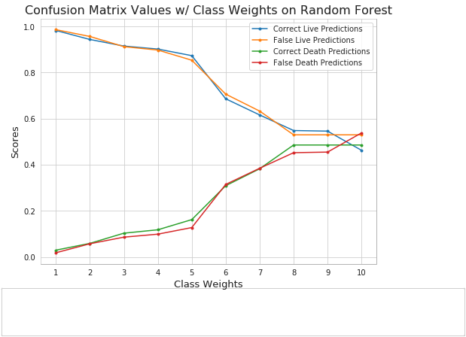

In [34]: # Plot different class weights influence on RF classifier

class_weights_plot(RandomForestClassifier, 'Class Weights Influence on Random Forest of X2')

https://eu-
gb.dataplatform.cloud.ibm.com/data/jupyter2/runtimeenv2/v1/wdpx/service/notebook/conda2py361254feaf150945e6bd9168002d10

0682/d… 40/40
7/3/2020 ML
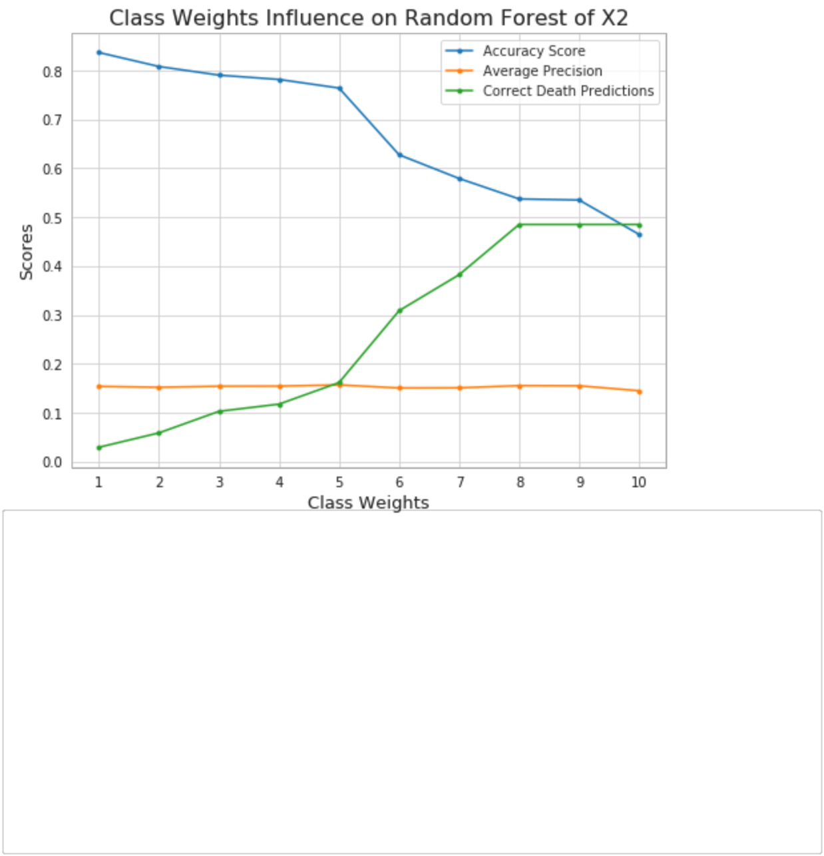

In [35]: # Grid Search Hyperparameters for Random Forest

rfc = RandomForestClassifier(random_state=1111)

param_grid = {

"n_estimators" : [5, 6, 7, 8, 9],
"max_depth" : [7, 8, 9, 10],

"min_samples_leaf" : [7, 8, 9, 10],

"class_weight": [None, 'balanced', {0: 1, 1: 5}]}

CV_rfc = GridSearchCV(estimator=rfc, param_grid=param_grid, cv= 5, scoring='av erage_precision') CV_rfc.fit(X2, y) print(CV_rfc.best_params_)

print('Best average precision score: {:.4f}'.format(CV_rfc.best_score_))

{'class_weight': None, 'max_depth': 7, 'min_samples_leaf': 8, 'n_estimators':

5}

Best average precision score: 0.2609

In [ ]:

https://eu-

gb.dataplatform.cloud.ibm.com/data/jupyter2/runtimeenv2/v1/wdpx/service/notebook/conda2py361254feaf150945e6bd9168002d10

0682/d… 41/41

